Trainer:_______________

Student # ___

- Day 1
  - Use the rule as a hint to catch the creature hidden in the classroom
  - Check off any that you caught
  - When you find the character with your Student #, snap an AR picture of it showing it hiding in its spot.
- Day 2
  - Go to Google Classroom and click on the “Gotta Catch’em All!” Google Slide assignment
  - Find your Slide with your Rule # (ex, Student #4 is Rule #4)

Always ask permission before using the computer. | 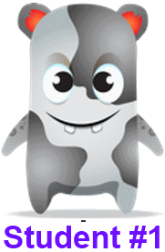 | Always be a good Digital Citizen. | 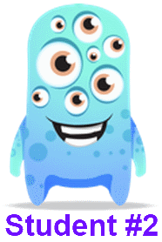
Keep all four legs of your chair on the ground. | 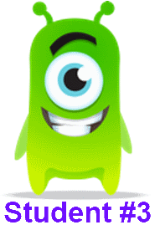 | Ask permission before using the Smart Board. | 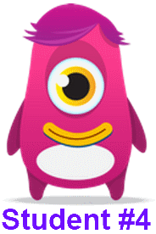
Ask permission before you print any material. |  | Return all Smart Board pens to the correct place. | 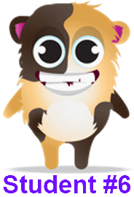
Double check you are not printing more pages than you need. | 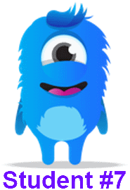 | Don’t be afraid to make mistakes. | 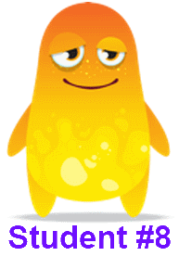
Keep hand away from electrical sockets. | 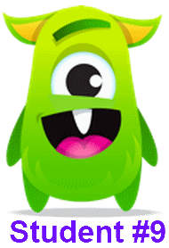 | Put all food waste in the compost bin. | 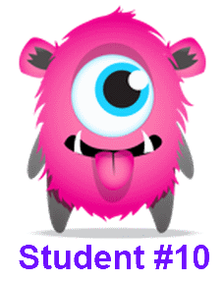
Make sure no garbage is left on the floor. | 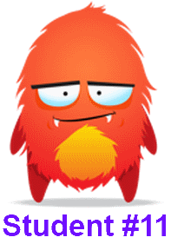 | Reduce the amount of paper that you use. | 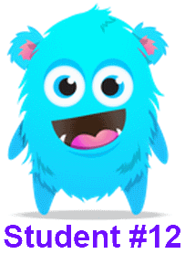
Hands are kept off the thermostat. | 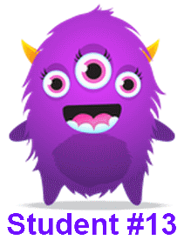 | The classroom door is to remain open when a teacher is not in the class. | 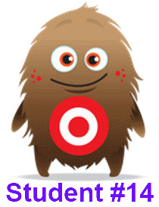
Ask the teacher for help whenever needed. | 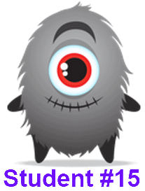 | Be sure to turn off your computer when finished. | 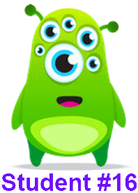
Ask permission before touching the curtains. | 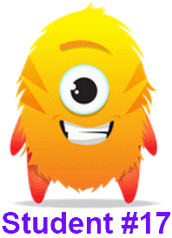 | Turn the lights off if you are the last one leaving the room. | 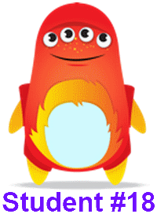
Follow fire drill directions calmly. | 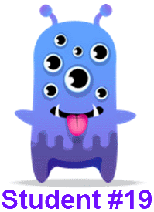 | Always remember who is in charge. :) | 