Step-By-Step Directions

1) 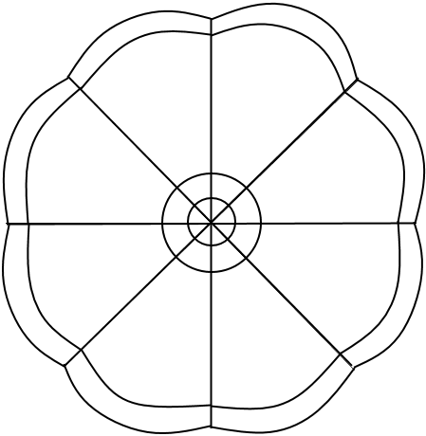 Put your name on the back of your flower sheet.
2) Label the first petal ‘Family’.
3) Fill in simple jot-notes about the makeup of your family.
- If you are having trouble, check out what others have written on the padlet site:
    - padlet.com/mrcaseyhrsb/family
4) Add your information to the padlet site for Family
5) Continue for the remaining petals:
- Language
- Sports
- Books
- Shows
- Food
- Hobbies
- Other
6) Colour in the flower without colouring over your written words.
7) Cut out your flower.
8) Double check your name is still on the back and then hand it to be displayed.

