Grade:_4/5_ Subject: _PBL (L.A./Math/Visual Arts)____
Time-frame: _1 week________
Click here for online copy found at mrcaseyhrsb.weebly.com
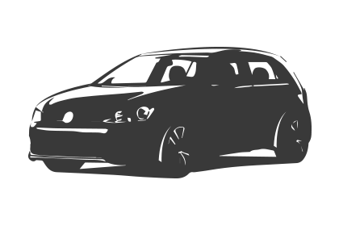Driving Question: How can we use character dialogue and green screen special effects to make a screencast to teach Mr. Casey something about Minecraft?

Learning Targets:

- Math
  - Gr. 4
    - SCO G01: Students will be expected to describe and construct rectangular and triangular prisms.
  - Gr. 5
    - SCO G01: Students will be expected to describe and provide examples of edges and faces of 3-D objects
- L.A.
  - Gr. 4
    - 8.3 experiment with language, appropriate to purpose, audience, and form, that enhances meaning and demonstrates imagination in writing and other ways of representing
    - 9.1 create written and media texts, collaboratively and independently, in different modes (expressive, transactional, and poetic) and in a variety of forms–recognize that particular forms require the use of specific features, structures, and patterns
  - Gr. 5
    - 8.3 make deliberate language choices, appropriate to purpose, audience, and form, to enhance meaning and achieve interesting effects in imaginative writing and other ways of representing
    - 9.1 create written and media texts, collaboratively and independently, in different modes (expressive, transactional, and poetic), and in an increasing variety of forms–use specific features, structures, and patterns of various text forms to create written and media texts
- Visual Arts
  - Gr. 4
    - 1.2 experiment with a range of materials and processes
    - 2.1 work individually and with others to solve problems and express ideas
    - 5.1 explore art as a way of expressing ideas and points of views
  - Gr. 5
    - 1.2 develop ability and initiative in the use of techniques, materials, and equipment
    - 2.1 work individually and collaboratively to apply learned skills, solve problems, and express ideas
    - 6.4 express personal ideas and points of view through their artwork
SPECIAL NOTE:
- Science
  - Instead of Minecraft, the screencast in this PBL could easily be about teaching a science fact from whichever unit is presently being studied.
  - This lesson however, as many PBLs benefit from, was born out of a strong interest from the students. What originally was simply an Hour of Code activity, turned out to be the perfect “Launch” for a Driving Question that was independently developed by the students.

Resources:
- Screencast on Dialogue
- Screencast on Minecraft cutout
- Screencast on Green Screen by DoInk
- Minecraft Cutout sheet
  - additional 3D nets for cutout found on website
- Directions for DoInk
- lined paper
- 3 green screens (suggestion: green plastic table cloth or shower curtain from Dollar Store)
  - additional green coloured items that could be used to prop things up or act as holders
  - extra green table cloth cut into 4 pieces (each can be used for invisibility cloak effect)
- 30 green Popsicle sticks
- 3 iPads equipped with Green Screen by DoInk App
- 26 Netbooks
- Point-to-View camera
- 3D shapes (Cube and a different rectangular prism)
- Rubric for group work

Preparation:
- Green Screen
  - When filming days arrive, it is easy to set up.
  - Completely clean white boards
  - use magnets on the corners of the green cloth to stretch across white board
    - (magnets and edges can be blocked out of digital copy if they are visible on screen)
  - make as smooth as possible
  - position iPad (on a cart/table/desk etc.) with screen facing the green screen so that students can see their image live, while they are filming their scene

Lessons Included

- PBL Launch: Hour of Code - uses Minecraft Hour of Code activity to introduce the usefulness of screencasts in teaching and build excitement for working with Minecraft characters

- Math: Building Character - creates Minecraft characters out of various rectangular prism nets to reinforce the 3D geometry outcomes covered in Gr. 4 and 5

- Language Arts: Writing Dialogue - students write out dialogue for screencast while focusing on conventions of writing such as capitals, punctuation, and quotation marks for speech.

- Filming: The Magic of Green Screens - students choose a background and take turns filming screencast using Green Screen technique

PBL Launch: Hour of Code

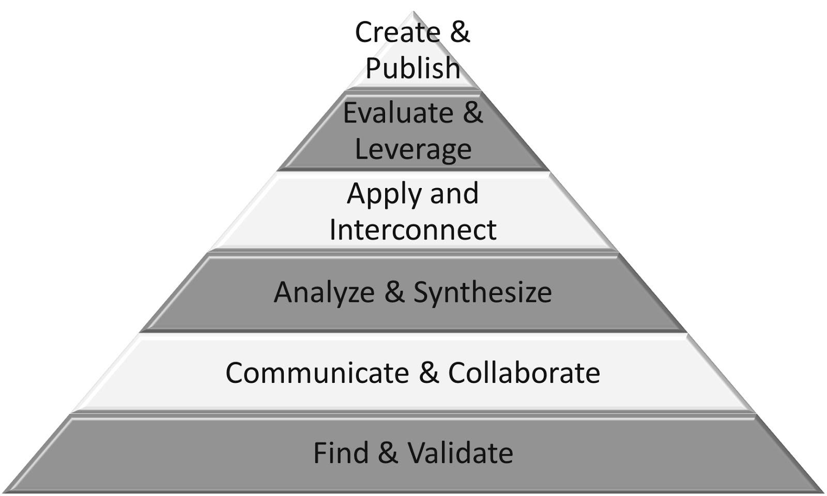
Part 1: (20 - 25 min) ✔

( ) Create & Publish
( ) Evaluate & Leverage
( ) Apply & Interconnect
( ) Analyze & Synthesize
(✔) Communicate & Collaborate
(✔) Find & Validate

Intro:
- Ask the students what they think a computer programmer does, who they are, and what they are like

- play Hour of Code video
  - Discuss who they saw in video
  - what were some of the main points
  - ask if they think they could become a Computer Programmer

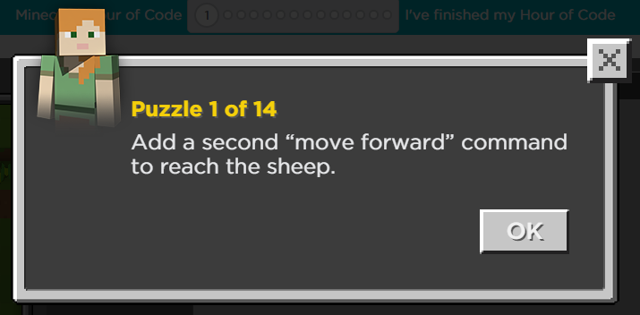
Explicit Teaching Teacher models/demonstrates

- On LCD projector, launch Minecraft Hour of Code page
  - click “Try Now” to launch Intro video

- Pick a character and show the class how to do Puzzle 1
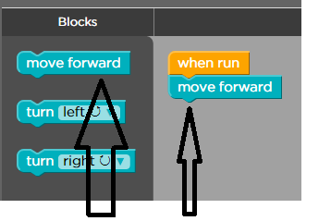
  - Bring attention to Directions by pointing and reading them out loud

- Show how to drag over command and attach to the existing “move forward” command.

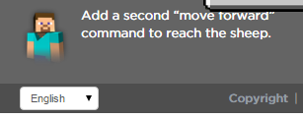

  - point out how the goal remains at the bottom left of the screen as a reminder.

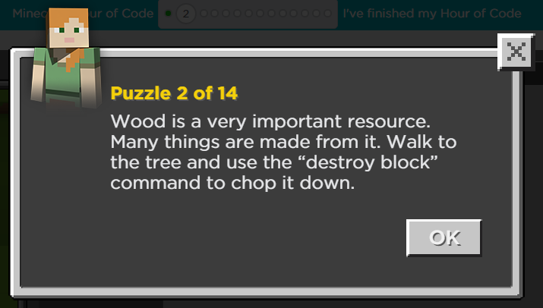
- Click ‘Run’ and then select ‘Continue” to go to the next puzzle.

- Reinforce that students read each step of directions by reading the next directions before ending the demonstration.

Part 2: (15 - 20 min) ✔
(✔) Create & Publish
(✔) Evaluate & Leverage
(✔) Apply & Interconnect
(✔) Analyze & Synthesize
( ) Communicate & Collaborate
( ) Find & Validate

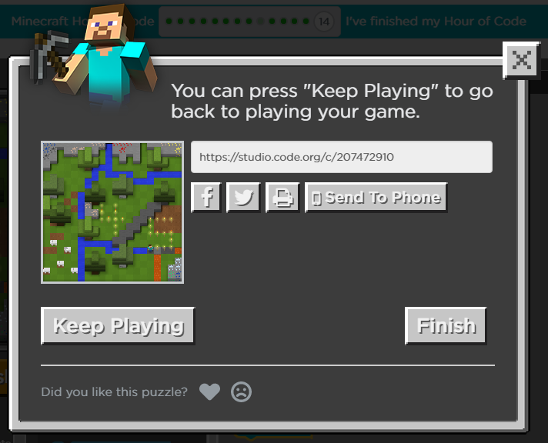
Independent/Groups

- each student takes a Netbook and logs onto code.org/mc (write address on white board)
  - remind them to pay attention to posted directions and information in embedded screencasts
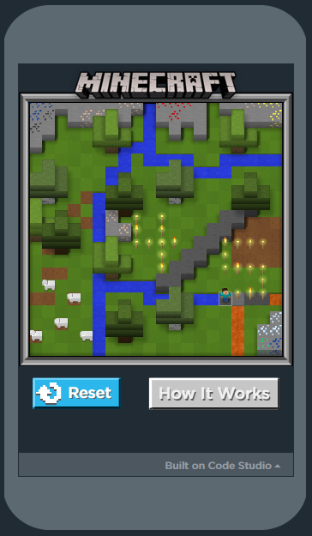
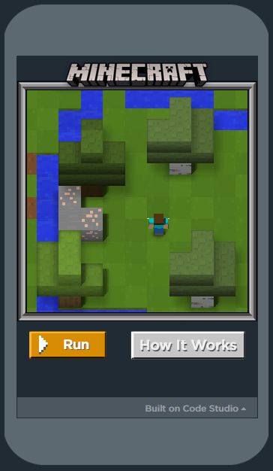
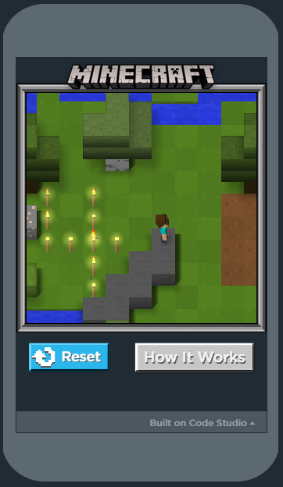
  - Also tell them to pay attention to the final screen. When they have made a program that does something special (like create 4/5 for our class), they can select ‘Finish’ on their main screen and then the window below pops up. They should highlight the posted address and paste it into our Google Classroom to share with the class.

- if shared, the address allows others to play your program and see what it creates and even check out your coding

- Click here to show the one I created and shared. 4/5 Casey

Part 3: 5-10 minutes

(✔) Create & Publish
(✔) Evaluate & Leverage
( ) Apply & Interconnect
( ) Analyze & Synthesize
( ) Communicate & Collaborate
( ) Find & Validate
Time to Share
- All Netbooks returned
- Use LCD to share any that were posted to the Google Classroom

Link to PBL
- ask the students what could you do to help those that do not understand how to play Minecraft

- have them think back to how the Hour of Code activity spread a few screencasts among the different levels in order to introduce, and teach, new concepts of coding like ‘repeat loops’ and ’if statements’.

- Remind them about how many teachers use screencasts in order to “flip” the instruction around, allowing learners to choose when a good time is for them to work on their understanding
  - Note: Mr. Casey would love to learn about Minecraft but might not feel class time is the right place to spend time learning about it. A screencast would allow you to teach him while he is at home and able to share it with his children, who would also like to learn.

- explain to the students that they will be making a Minecraft character out of paper and filming a conversation with a partner’s character in order to teach something about Minecraft.

- It will be done in front of a green screen so they will get to chose their own background image to be behind them.

- The script will need to be typed out ahead of time to ensure the scene is ready for filming.

- If a pair of students do not know Minecraft well enough to teach something about it, they may propose an alternative piece of information to teach the viewer on a different topic.

Post the driving question:
- How can we use character dialogue and green screen special effects to make a screencast to teach Mr. Casey something about Minecraft?

Math: Building Character

Part 1: (20 - 25 min) ✔

( ) Create & Publish
( ) Evaluate & Leverage
( ) Apply & Interconnect
( ) Analyze & Synthesize
(✔) Communicate & Collaborate
(✔) Find & Validate

Intro:
- ask students,
  - What shapes appear to be common in Minecraft?
  - What is the difference between a cube, and a rectangular prism?
  - If you were to make a Minecraft character, what shapes might you need?

Explicit Teaching Teacher models/demonstrates

- Hold up a rectangular prism and ask how to define it (write valid statements on board)
  - 6 faces
  - all faces rectangles
  - all sides meet perpendicular
- Hold up a cube and see if it fits all given requirements for a rectangular prism
  - reminder that a square is a rectangle (4 sided shape with opposite sides equal in length and parallel)
- Ask how to define a cube?
  - 6 faces
  - all faces rectangles
  - all sides meet perpendicular
- Hold up the rectangular prism and ask if it fits all given requirements for a cube
  - remind them that because not all rectangles are squares, this specific prism is not a cube

Part 2: (15 - 20 min) ✔
(✔) Create & Publish
(✔) Evaluate & Leverage
(✔) Apply & Interconnect
(✔) Analyze & Synthesize
( ) Communicate & Collaborate
( ) Find & Validate

Independent/Groups

- play Screencast video of making prism characters
- handout sheets
- play the video a few times while students make character
- have additional 3D shape nets available for students that want to make something different

Part 3: 5-10 minutes

(✔) Create & Publish
(✔) Evaluate & Leverage
( ) Apply & Interconnect
( ) Analyze & Synthesize
( ) Communicate & Collaborate
( ) Find & Validate
Time to Share
- students show class finished characters and describe them with proper terms (faces, base, edges, vertices etc)

Language Arts: Writing Dialogue

Part 1: (20 - 25 min) ✔

( ) Create & Publish
( ) Evaluate & Leverage
( ) Apply & Interconnect
( ) Analyze & Synthesize
(✔) Communicate & Collaborate
(✔) Find & Validate

Intro:
- everyone takes out their own reading books and looks for a sample of dialogue within the text
  - Note: great discussion possible around why those reading Graphic Novels will not have samples of dialogue

Explicit Teaching Teacher models/demonstrates

- read your own example of dialogue from a book found on the shelf
- use Point-to-View camera to project an image of the page onto whiteboard
- use whiteboard marker to bring attention to quotation marks, capitals, and punctuation marks
- play Dialogue screencast
- leave last image of the dialogue examples up on screen for Part 2 of the lesson

Part 2: (15 - 20 min) ✔
(✔) Create & Publish
(✔) Evaluate & Leverage
(✔) Apply & Interconnect
(✔) Analyze & Synthesize
( ) Communicate & Collaborate
( ) Find & Validate

Independent/Groups
- handout Netbooks
- every student logs into their own gnspes.ca accounts
- one student from each pair goes into Google Classroom and opens a Google Doc within the Dialogue assignment.
- that student then “shares” the file with the partner (making sure permissions are set on ‘Can edit’)
- Students work together in one Google Doc, on separate Netbooks, to write dialogue for their scene.
- They are specifically responsible for typing the dialogue for their own character (recommend the two partners pick two different font colours)
  - they are asked not to type in corrections for their partner’s sentences
  - if they see something they think their partner needs to correct, they are to verbally inform them and let them make the corrections themselves
  - remind them that it should be clear when the teacher looks at editing history, that each student typed their own character’s portion of the dialogue

Part 3: 5-10 minutes

(✔) Create & Publish
(✔) Evaluate & Leverage
( ) Apply & Interconnect
( ) Analyze & Synthesize
( ) Communicate & Collaborate
( ) Find & Validate
Time to Share
- Student groups that are finished, take turns reading their dialogue to the class
- occasionally can call up an example to the LCD to reinforce different placement of the speaker tag (beginning, middle, end)

Note:
- this may take a few days to finish
  - can start each session with a new example on the board or play the screencast again
  - have some students share their partial or finished dialogue
  - students continue to work on dialogue
  - those that are finished their dialogue can work on finishing making characters or additional props and then rehearse
  - come back together as a class at the end to share a few new examples of finished work

Filming: The Magic of Green Screens

Part 1: (20 - 25 min) ✔

( ) Create & Publish
( ) Evaluate & Leverage
( ) Apply & Interconnect
( ) Analyze & Synthesize
(✔) Communicate & Collaborate
(✔) Find & Validate

Intro:
- Show clips of past screencasts that used the green screen
  - Screencast on Opaque, Translucent, and Transparent
  - Screencast on Dialogue

Explicit Teaching Teacher models/demonstrates
- Play DoInk’s screencast on how to use the app

- set up an iPad pointing at one of the class green screens while broadcasting on Airserver to LCD
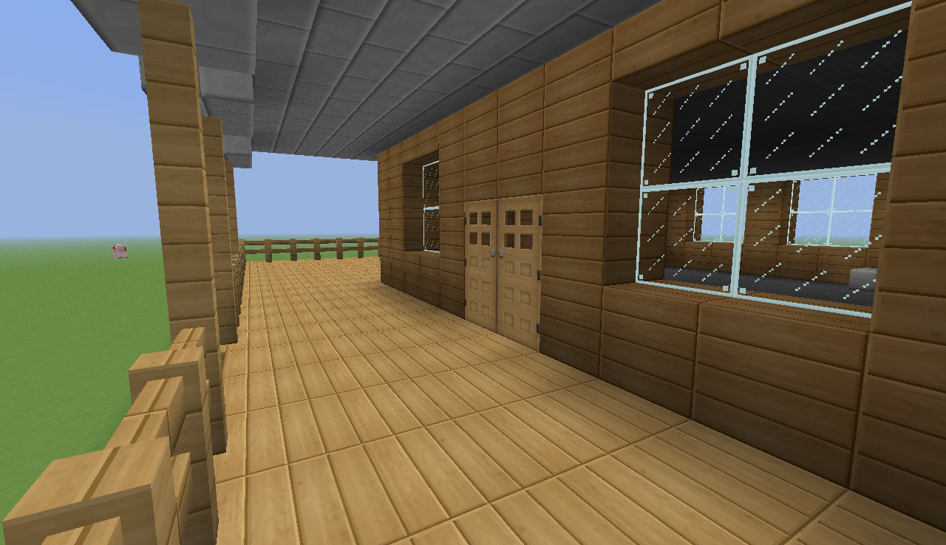
- demonstrate to class how to choose a background image
  - search online for image with “background minecraft house” to find one that matches my needs for my scene
  - save to photo gallery

- shoot a video
  - using the regular video app, shoot a quick video of one of the characters in front of the green screen

- open DoInk App
  - select + in top right corner to ‘Create a new project’ (if already in a project, select back arrow in top left corner to get to project choice screen)

  - Add Background Picture
    - select the + on the right of the bottom stream to add your background ‘image’

  - Add Character Video
    - select the + on the right of the middle stream to add your green screen ‘video’

  - Prepare Audio
    - select the + on the right of the top stream to select ‘camera’
      - while the top stream is outlined in red, select the mask icon on the right, just above to top stream’s blue +
      - slide sensitivity to 100%
      - tap screen to make image disappear
      - select done
  - Adding Audio
    - make sure the class is silent, (when it is their turn, they will be doing this part in a quiet place in the hallway)
    - click the red record circle (the word VIDEO to its right should be blue)
    - record your voice adding the dialogue to the scene as the character moves around
    - press square icon to stop when finished
    - select ‘Adjust the audio’ and slide the ‘Prerecorded Audio’ down to 0%
    - select ‘Done’

  - Saving Video
    - select ‘Show the export options’
    - slide icons of options over to reveal ‘Google Drive’ and select it
    - you can select ‘CANCEL’ but show students where they would select to log into their own gnspes.ca account and then would select ‘UPLOAD’
    - they would then go into their Google Drive and share their video with their partner and teacher

Part 2: (15 - 20 min) ✔
( ) Create & Publish
(✔) Evaluate & Leverage
(✔) Apply & Interconnect
(✔) Analyze & Synthesize
( ) Communicate & Collaborate
( ) Find & Validate

Independent/Groups
- print out steps
- pairs all work on Netbooks or iPads to find background image they like and save to their Google Drive
- when students are ready, they may take the spot at one of the three available iPad filming stations
Part 3: 5-10 minutes

(✔) Create & Publish
(✔) Evaluate & Leverage
( ) Apply & Interconnect
( ) Analyze & Synthesize
( ) Communicate & Collaborate
( ) Find & Validate
Time to Share
- students any new finished products with class,
- will share with parents at Student-Led Conferencing style Parent-Teacher night
- also, will play to school at next school assembly

Directions for DoInk

  - Add Background Picture: to the bottom stream

  - Add Character Video: to the middle stream

  - Prepare Audio
    - select the + on the right of the top stream to select ‘camera’
      - while the top stream is outlined in red, select the mask icon on the right, just above to top stream’s blue +
      - slide sensitivity to 100%
      - tap screen to make image disappear
      - select done

  - Adding Audio
    - make sure the class is silent, (when it is their turn, they will be doing this part in a quiet place in the hallway)
    - click the red record circle (the word VIDEO to its right should be blue)
    - record your voice adding the dialogue to the scene as the character moves around
    - press square icon to stop when finished
    - select ‘Adjust the audio’ and slide the ‘Prerecorded Audio’ down to 0%
    - select ‘Done’

  - Saving Video
    - select ‘Show the export options’
    - upload into ‘Google Drive’

Teacher Rubric for Group Work

The teacher will use this rubric to evaluate your group's work as a team.

Team members: _____________________________________________________

 | Beginning  1 point | Developing  2 points | Accomplished  3 points | Exemplary  4 points
Contribution | One or more members do not contribute. | All members contribute, but some contribute more than others. | All members contribute equally. | All members contribute equally, and some even contribute more than was required.
Cooperation | Teacher intervention needed often to help group cooperate. | Members work well together some of the time. Some teacher intervention needed. | Members work well together most of the time. | All members work well together all of the time; assist others when needed.
On task | Team needs frequent teacher reminders to get on task. | Team is on task some of the time. Needs teacher reminders. | Team is on task most of the time. Does not need any teacher reminders. | Team is on task all of the time.  Does not need any teacher reminders.
Communication | Members need frequent teacher intervention to listen to each other and speak to each other appropriately. | Members need some teacher intervention to be able to listen to each other and speak to each other appropriately. | All members listen to each other and speak to each other in equal amounts. | Each member listens well to other members. Each member speaks in friendly and encouraging tones.

(Created by Janet Bowland, Fayette County Schools)

Resources

http://learninginhand.com/blog/drivingquestions
http://wvde.state.wv.us/teach21/PrimaryRubrics.html
http://artforkidshub.com/how-to-make-steve-papercraft-cutout/

