Grade:_4_ Subject: _L.A.____ Time-frame: _60 min________
Click here for online copy found at mrcaseyhrsb.weebly.com
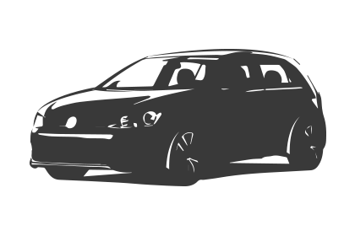Driving Question: “Do my books really use all this stuff?” Beyond textbooks and teacher chosen examples, can most of the text features even be found in the pieces of non-fiction students are interested in reading, and if so, how easy are they to find?

Learning Targets:
- Non-fiction text
  - 7.2 identify conventions and characteristics of different types of print and media texts that help them understand what they read and view

- Additional ELA Outcomes
  - 8.3 Experiment with different ways of making notes (e.g. webbing, jot notes, matrix)
  - 9.1 Create written and media texts, collaboratively and independently, in different modes and in a variety of forms
  - 10.3 Use technology with increasing proficiency in writing and other forms of representing
  - 10.5 Select, organize, and combine relevant information from two or more sources to construct and communicate meaning

Resources:
- LCD Projector
- 13 iPads
- Large selection of Non-Fiction texts
- Backup set of Plickers Cards (1-26) (Students should have ones with magnetic tape stuck under their desks.)
- Common Features of Non-Fiction Books (26 copies)
- Padlet QR codes print out (not back to back)
- Screencast on Padlet for Non-Fiction Features
- Prezi on Newspapers and Non-Fiction Text Features
- Rubric
- Prezi on Ins & Outs of Padlet

Preparation:
- Set up Plickers (see demo video of Plickers found on YouTube)
  - on class computer log onto www.plickers.com with Login: ****** and Password:******
  - login using App on iPad (or personal phone if you have App --> Apple or Google Play)
  - Click on “Mr. Casey 4/5"
  - It should be in Queue mode, select the top question “How many different features do..”
  - The Live view on the computer should also be displaying the question.
  - You are all ready to go!
- View Prezi on Ins & Outs of Padlet
  - It contains samples of the image scavenger hunt being done in this lesson

Adaptations (Child Specific):
- (*, *, & *) - printout of the Step-By-Step Directions
    - Check in to ensure they are properly participating with their partner

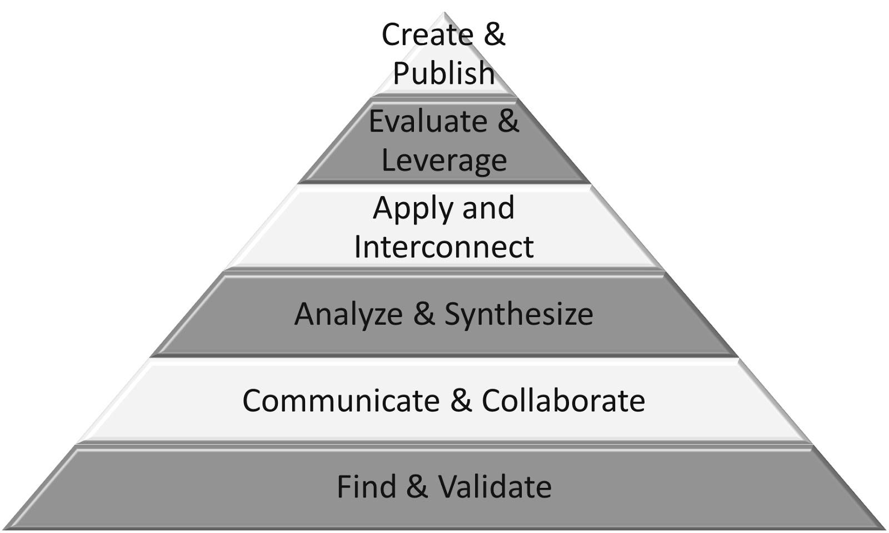
Part 1: (20 - 25 min) ✔

( ) Create & Publish
( ) Evaluate & Leverage
( ) Apply & Interconnect
(✔) Analyze & Synthesize
(✔) Communicate & Collaborate
(✔) Find & Validate

Connection

Introduction:
- reshow slides of Prezi, focusing on newspaper and math textbook samples
  - click on full screen icon in bottom right of presentation screen
  - 5 advance clicks (right arrow on keyboard) should get you to Non-Fiction Text Features slide
  - Review the features shown there and then continue past the Groucho Marx quote onto the math text example on the Finding Fabulous Non-Fiction Features slide and review them as well
- point out how those were selected by the teacher as good examples but that not all texts are the same

- Pose the driving question:
  - Beyond textbooks and teacher chosen examples, can most of the text features even be found in the pieces of non-fiction you are interested in reading?

- Activate 1st Plickers question: (Should look like image below)

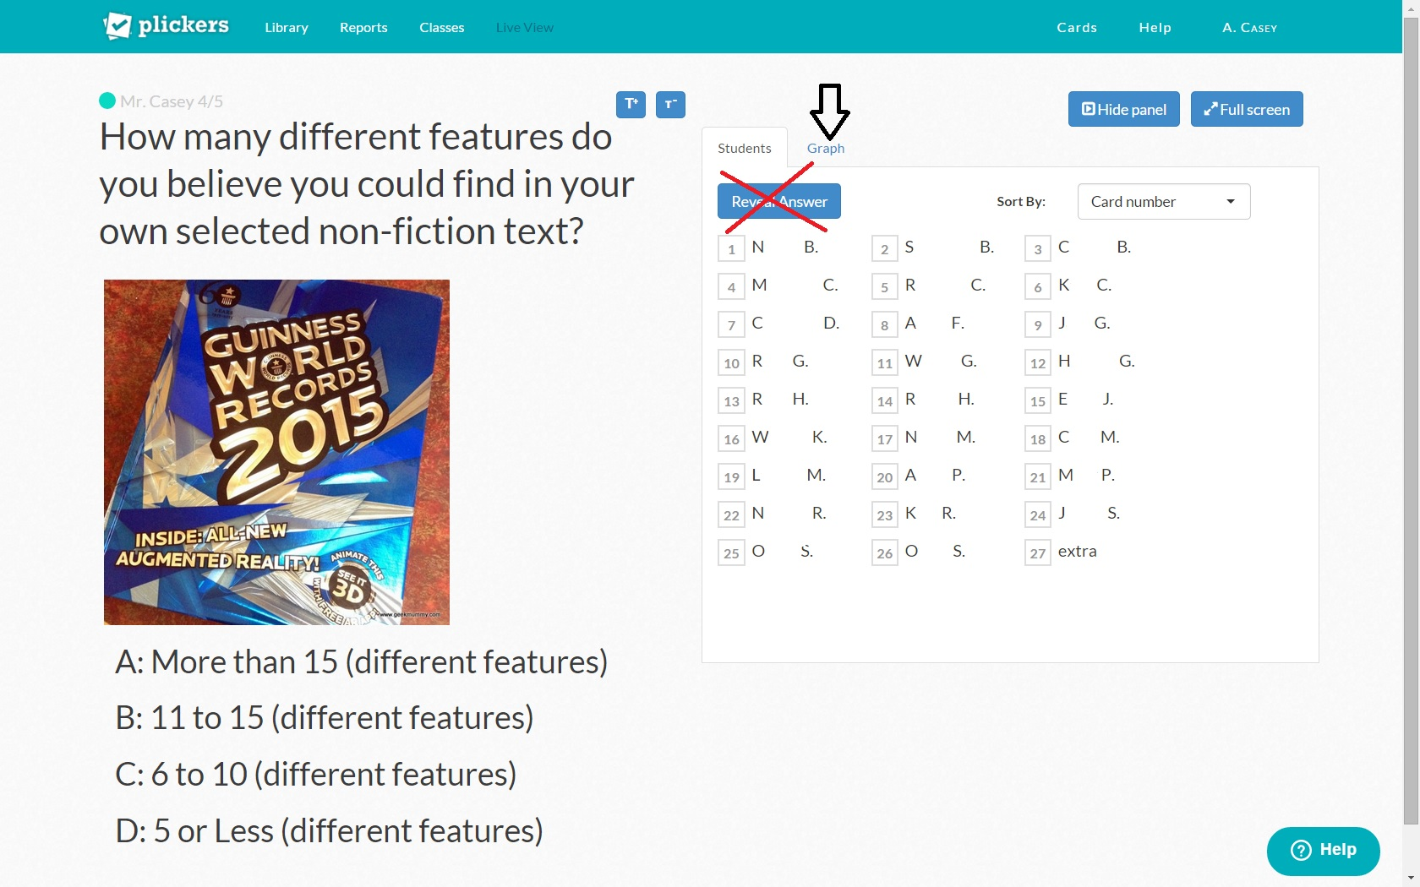

- students hold up their Plicker sheets to correspond with their intended answer
- Click the camera on your hand held device and scan the room to read the Plicker sheets
- Their number with their name beside will be checked off to indicate that theirs has been read (actual live view shows full student name)
- After all students have been scanned, you can click on the Graph tab (as indicated by the arrow in the image above) to see how the class scored
- Do not click on the “Reveal Answer” button because the students do not need to see how each individual answered.

Reflecting on prior teaching:
- Ask students how many features they can recall
  - write name of each feature on board and read definition off of list

Guided Practice
- distribute new copy of Common Features of Non-Fiction Books
- have them add a second underline to the ones on their list that were named and written on the board
- take volunteers to read definitions of ones not yet named while class adds second underline to acknowledge they were also discussed

Explicit Teaching Teacher models/demonstrates
- hold up a sample of non-fiction and a sample of fiction and point out how they look extremely different.
- The piece of fiction usually has a chapter heading, some illustrations, and a lot of uninterrupted writing. Not many different features to find.
- Graphic novels do add more features (speech, thought, and caption writing) to replace the conventional text but how does that compare to most samples of non-fiction?

Part 2: (15 - 20 min) ✔
(✔) Create & Publish
(✔) Evaluate & Leverage
(✔) Apply & Interconnect
( ) Analyze & Synthesize
( ) Communicate & Collaborate
( ) Find & Validate

Independent/Groups

Practice/Conference focus:
- Show screencast on how to use Padlet for displaying Non-Fiction text features
- Project Step-By-Step Directions (following lesson)
- Tell students their partner’s name and group number
- Students collect 1 iPad per group and find sheet with corresponding group # QR code to connect to proper site.
- While students are working on their feature scavenger hunt, have the screencast available on the second class computer screen for students to access at any time they are having difficulties.
- Move around groups to ensure they are recording the information properly on heir sheet, following all the steps for Padlet, and not waiting around while their partner is on the computer.
- After all groups have reached step 6 in the directions and are no longer in need of the projection, change the screen to the website link to show all the Padlet boards in real time.

Part 3: 5-10 minutes

(✔) Create & Publish
(✔) Evaluate & Leverage
( ) Apply & Interconnect
( ) Analyze & Synthesize
( ) Communicate & Collaborate
( ) Find & Validate
Time to Share
- Have all students return the iPads and remember to unlock the guided access (code ----) before putting them back in bins
- Do quick tour through the Padlet sites by starting at padlet.com/mrcaseyhrsb/nonfiction1
- Return to Plickers and ask final questions in the queue:

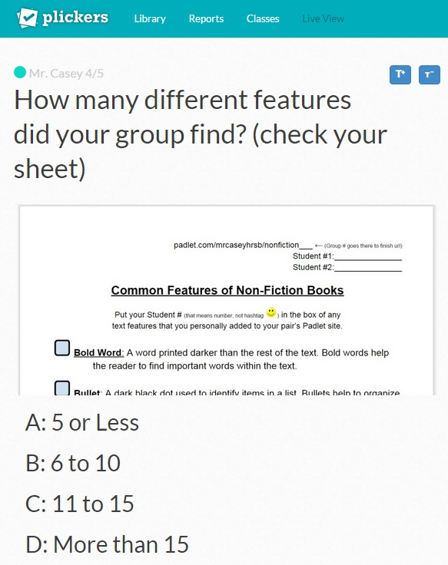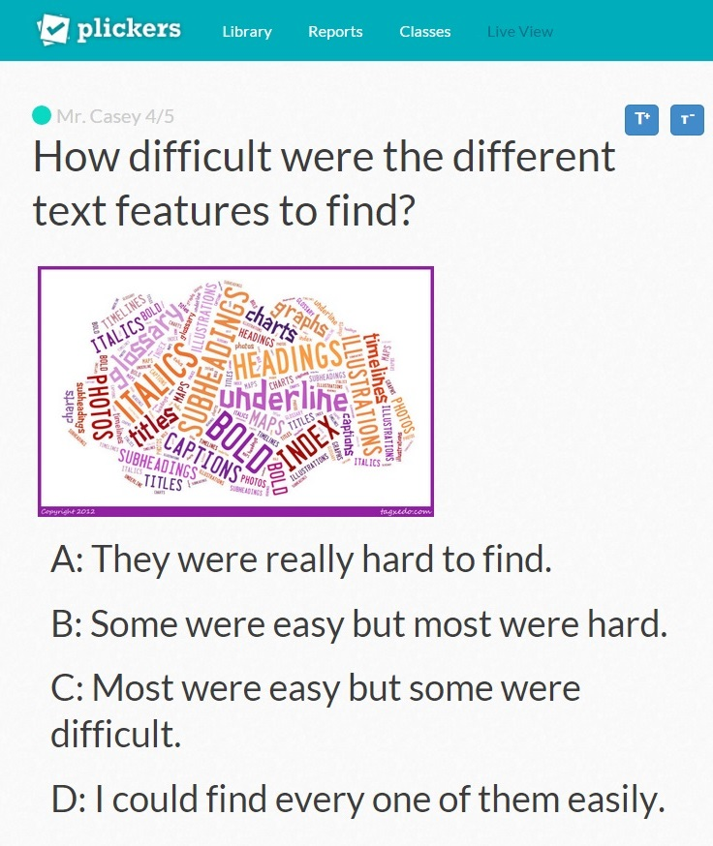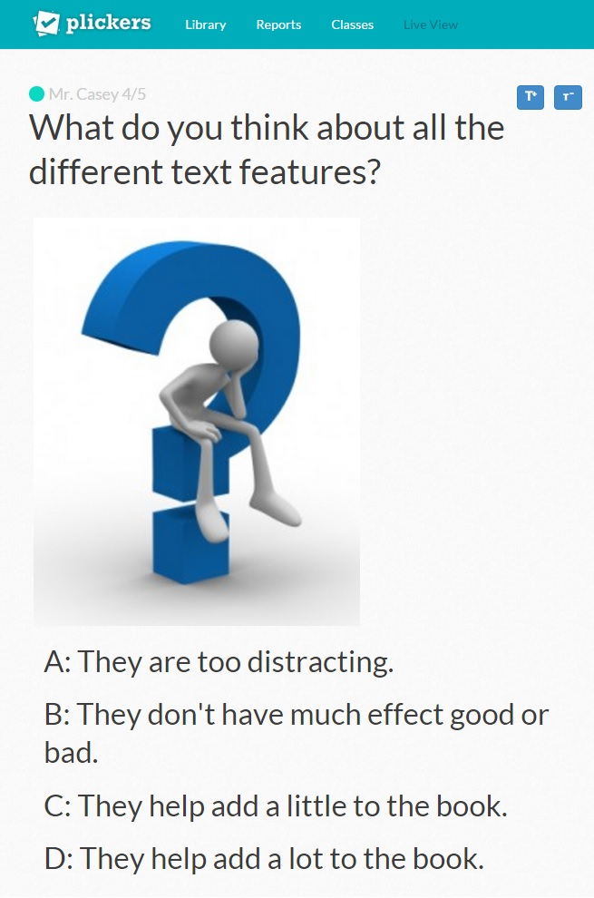

- Wrap up with overall discussion on final question.
- use rubric to assess sites

Reflection:

I’ve always enjoyed using Plickers because the students are always engaged during the activity and don’t hesitate to show their excitement when I tell them to bring out their Plicker squares. This time I increased the personal touch by taking the extra seconds necessary for adding images. Whether it is to help clarify the question or simply for fun, the site does make it very easy to add images so I will likely keep that up in the future.
I believe I need to make a screencast though, that would help the students on how to properly hold the cards because I still found myself having to remind them. It could be done in a way to be an instruction for other teachers (or subs) on how to work the program as well. I will likely include that as a future 21st Century Lesson.
Padlet worked great for this lesson as well. It was because Padlet is such a versatile web-based program (works on any device with internet, no App required), that I like using it in the classroom. Students can use any smart phone, iPod, tablet, and even Netbook, if the camera is activated. For this lesson I stayed with iPads in order to keep it more contained and since I was pairing them up, we had exactly the right number of devices.
The embedding of the Padlets into the website did not turn out as I had hoped. The images stayed too large to display more than a few at a time. It also opens up interaction by the public. I believe settings can be made to require sign in to each Padlet but then the ease of starting the activity is lost.
The lesson itself was meant to be a wrap up for the unit but it did require more follow up than I expected. Students did demonstrate their different levels of ability and knowledge on finding non-fiction text features but I did need to supplement the rubric of the Padlet page with some teacher conferencing. Many students excelled with the scavenger hunt while others did struggle a little. For them, the independent work on the Padlet site and a personal conversation with me asking for more detail was needed to ensure I was truly finding out their level of knowledge of non-fiction text features.

Step-By-Step Directions

1) Write your name, partner, and Group # on your sheet.
2) Use the QR Code sheet to log onto Padlet Group page.
3) Use your own selected Non-Fiction text to find examples of text features listed on your handout.
4) Take turns entering information on Padlet site
- double tap
- as ‘Title’ put the name of the text feature
- as ‘Write something …’ put your initials
- tap camera icon, ‘upload/use camera’, and then ‘Take Photo/Video’
- take picture of close up on feature
- if in focus and close enough, click ‘use photo’ then ‘O.K.’
5) Record your Student # in box beside any feature you record.
6) Keep track of what your partner has completed by writing their number on your paper beside the ones they complete.

Rubric: Non-Fiction Text Feature Scavenger Hunt

  - 7.2 identify conventions and characteristics of different types of print and media texts that help them understand what they read and view

Group # | Student Name | 4  Full variety of examples clearly displayed and labeled | 3  Some variety of examples displayed and labeled | 2  Very few examples displayed or labeled | 1  Either one or no examples displayed properly with correct label
1
1
2
2
3
3
4
4
5
5
6
6
7
7
8
8
9
9
10
10
11
11
12
12
13
13
padlet.com/mrcaseyhrsb/nonfiction___ ← (Group # goes there to finish url)

Student #1:_______________

Student #2:_______________

Common Features of Non-Fiction Books
Put your Student # (that means number, not hashtag ) in the box of any text features that you personally added to your pair’s Padlet site.
Bold Word: A word printed darker than the rest of the text. Bold words help the reader to find important words within the text.

Bullet: A dark black dot used to identify items in a list. Bullets help to organize information.

Caption: Words to explain an illustration or photo. Captions are usually underneath or beside the illustration or photo.

Chart: Information presented in rows and columns. Charts are used to organize a lot of information in a small space. They are easier for the reader to gain information from because they are a visual representation of information.

Cutaway: An illustration to show what something looks like on the inside.

Glossary: A list of keywords used in the book, and their definitions. The glossary is at the end of the book. The glossary often also has a pronunciation key to help the reader say the word correctly.

Graph: A diagram to help the reader understand statistical information.

Illustration: A photograph, drawing or diagram to show the reader exactly what something looks like. Illustrations are used to support the text… if there is a visual to go along with the text it makes a more lasting impact on the reader.

Index: A detailed list of the topics discussed in the book, arranged in alphabetical order with the numbers of all the pages on which the topic is mentioned. The index is at the end of the book.

Italic and other types of print: Italics is a type of print where the text is slanted. It is used to highlight information that is important by making it look different from the rest of the text.

Label: Words used to identify parts of something in an illustration. Often an arrow or line connects the label to the part of the illustration.

Map: A drawing of parts of the earth’s surface to provide information about the location of things in the world.

Section Heading: Words at the beginning of sections of text to tell the reader what the following text is about. Section headings can also be called subtitles.

Sidebar: Detailed information about the topic set apart from the rest of the text by lines, boxes or use of colour. The sidebar is important to readers because it gives additional information. Sidebars quite often start with “Did you know?” or “Interesting Fact”.

Speech Bubble: A balloon with text printed inside. Speech bubbles are used in illustrations to show what the characters are saying.

Symbol: A picture that stands for something in the real world. Symbols are usually used throughout the book.

Table of Contents: Is an ordered list of what is in the book, it is like a map of the book. The Table of Contents is at the beginning of the book.

Title: Words set apart from the text at the beginning of books and chapters.

Group 1 | Padlet Non-Fiction QR Codes
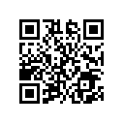
 |  | Group 2
 |  | 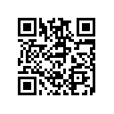
Group 3
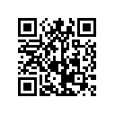
 |  | Group 4
 |  | 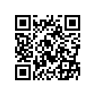
Group 5
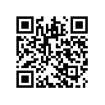
 |  | Group 6
 |  | 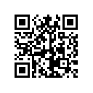
Group 7
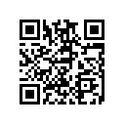
 |  | Group 8
 |  | 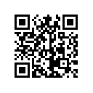
Group 9 |  | Group 10
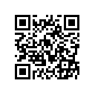 |  | 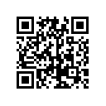
 | Group 11
 | 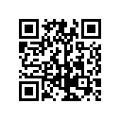
Group 12 |  | Group 13
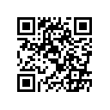 |  | 