Grade:_4_ Subject: _Science____ Time-frame: _60 min________
Click here for online copy found at mrcaseyhrsb.weebly.com
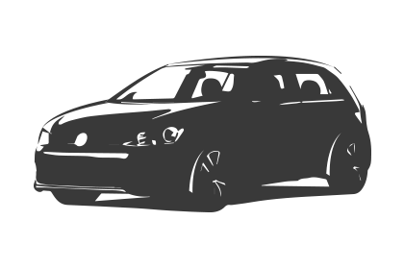Driving Question: We have learned that light can be reflected or absorbed but what happens if all or some of the light passes through the object? How do you classify objects in that respect?

Learning Targets:
- Science
  - Classify objects as opaque, transparent, or translucent

Additional Outcome
- Math
  - SCO SP02 Students will be expected to construct and interpret pictographs and bar graphs involving many-to-one correspondence to draw conclusions.

Resources:
- LCD Projector
- Screencast on Opaque, Translucent, and Transparent
- Backup set of Plickers Cards (1-26) (Students should have ones with magnetic tape stuck under their desks.)
- 6 flash lights - extra batteries
- Recording Sheet: Opaque, Transparent, or Translucent?
- 6 container bins
- Materials to test - white paper - wax paper
  - spoon - black construction paper - leaf
  - glass of water - tin foil - plastic ziplock

Preparation:
- Have 6 bins, each containing
  - samples of each material needed
  - a working flash light
  - 5 copies of handout
- Set up Plickers (see demo video of Plickers found on YouTube)
  - on class computer log onto www.plickers.com with Login: ****** and Password:******
  - login using App on iPad (or personal phone if you have App --> Apple or Google Play)
  - Click on “Mr. Casey 4/5"
  - It should be in Queue mode, select the question “Prediction #1 ...” (click here for copy of questions)
  - The Live view on the computer should also be displaying the question.
  - You are all ready to go!
- SPECIAL NOTE:
  - If you would like to use these Plickers questions with their images but do not have access to my queue nor have the time to create your own, try the following!
    - use the LCD projector to show a copy of the questions (click here) not in Plickers
    - then simply type each question # and item, as new questions, on your hand-held device’s Plicker App (“Pred. #1 white paper”, “Pred. #2 wax paper”, …. “Result #11 hand”)
    - you can even leave choice A, B, C, and D blank because students will not see it
    - While showing the LCD image of the full question, record the students’ responses on your hand held device with your simplified questions.

Adaptations (Child Specific):
- (*, *, & *) - printout of the Step-By-Step Directions
    - Check in to ensure they are properly participating with their partners

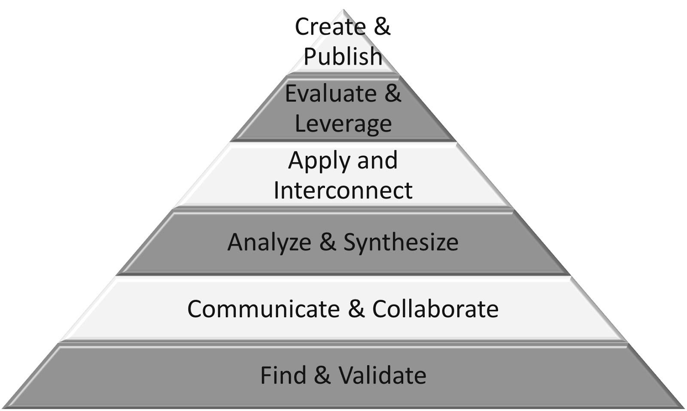
Part 1: (20 - 25 min) ✔

( ) Create & Publish
( ) Evaluate & Leverage
( ) Apply & Interconnect
(✔) Analyze & Synthesize
(✔) Communicate & Collaborate
(✔) Find & Validate

Connection

Introduction:
Reflecting on prior teaching:
- review how we see things because light is reflected and/or absorbed by things

- Pose the driving question:
  - We have learned that light can be reflected or absorbed but what happens if all or some of the light passes through the object?

- Activate 1st Plickers question: (Should look like image below)

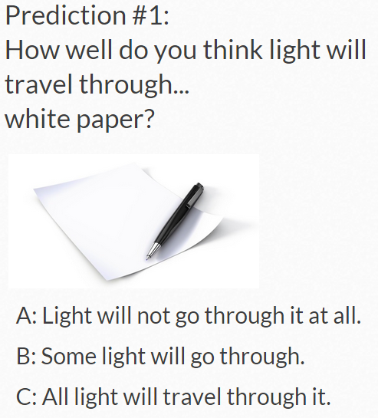

- Students hold up their Plicker sheets to correspond with their intended answer
- Click the camera on your hand held device and scan the room to read the Plicker sheets
- Their number with their name beside will be checked off to indicate that theirs has been read (actual live view shows full student name)
- After all students have been scanned, you can click on the Graph tab (as indicated by the arrow in the image above) to see how the class scored
- Do not click on the “Reveal Answer” button because the students do not need to see how each individual answered.

- Review the predictions by revisiting the questions in Plickers while on Graph View (example)

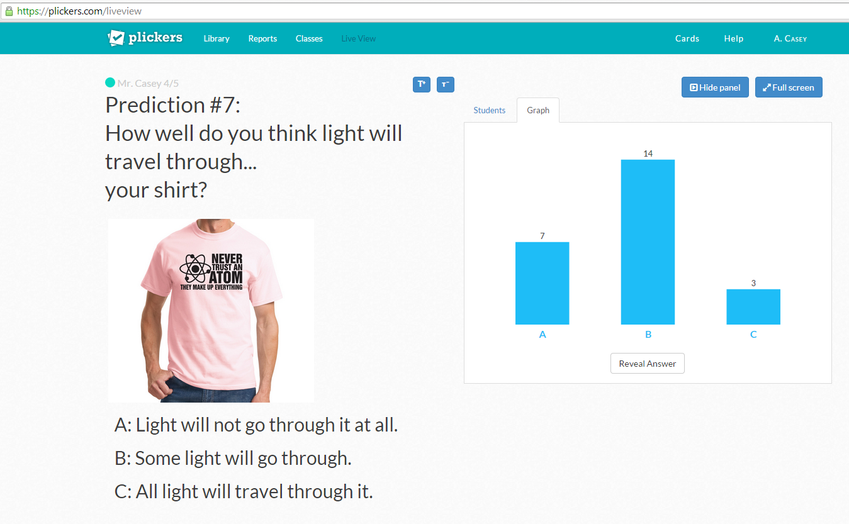

  - Have students try and describe what the data is demonstrating
    - Were the predictions all the same or did they show uncertainty?
  - What information is missing to make this a properly labeled graph?
    - How could that information help?
    - What type of intervals would you use to label the vertical axis, other than one-to-one?

Guided Practice

- Pose 2nd part of Driving Question
  - How do you classify objects in respect to how much light travels through it?

- Discuss different suggestions for descriptions.

Explicit Teaching Teacher models/demonstrates

- Show screencast on Opaque, Translucent, and Transparent

Part 2: (15 - 20 min) ✔
( ) Create & Publish
( ) Evaluate & Leverage
(✔) Apply & Interconnect
(✔) Analyze & Synthesize
(✔) Communicate & Collaborate
( ) Find & Validate

Independent/Groups

Practice/Conference focus:
- handout recording sheet: Opaque, Transparent, or Translucent?
  - direct them to the vocabulary and helpful Smile Face image on top of page
- Hand out material bins and have them start their experiments (turn off lights if possible)
  - walk around to reinforce use of proper vocabulary and that students are assessing the results accurately

  - SPECIAL NOTE:
    - I had the Plickers Result questions already entered but without the corresponding image so that I could show an image of the actual item being tested
    - a fun option is to use the iPad to snap pictures of the students while doing the experiments to use in the Plickers results
    - then use the plickers.com in the web browser (not the App) to add the images into the pre-typed questions

- When all students have answers recorded (including #12 extra item), collect up bins of material

Part 3: 5-10 minutes

(✔) Create & Publish
(✔) Evaluate & Leverage
( ) Apply & Interconnect
( ) Analyze & Synthesize
( ) Communicate & Collaborate
( ) Find & Validate
Time to Share
- Collect Plickers of results

- review results in Graph Mode as you go (do not reveal individual answers)
  - Ask how many think the result was different from what they originally predicted.
    - discus how the goal is not to have predictions that match results. Discoveries are made if the result is different than what was expected.
  - Ask why there still appears to be some differences in how some students recorded their results.
    - Note that it may be difficult in deciding whether enough light is getting through in order to call it Transparent.
    - Scientifically, some individual beams of light may not get through the item but it still may be considered transparent because of the large number that do.
    - Also, some light rays might slightly change their direction, altering the image but still travel through the object.

- Wrap up with a closing discussion on the terms Transparent, Translucent, and Opaque

Step-By-Step Directions

1) Write your name on your sheet.
2) Pick an item from the container and find it on your list.
3) If there is not a flashlight available, wait your turn.
4) Test to see if light can pass through the object
- completely so I can see through it with no problem (transparent)
- I can see light but not all of it (translucent)
- I can’t see any light through it (opaque)
5) Record a check mark under the column that fits your findings.
(transparent, translucent, or opaque)
6) Return the item to the bin and choose another item to test.

7) If you viewed another group member do an experiment and can conclude whether their material is definitely transparent, translucent, or opaque, you may record that finding. However, if you are not certain what the results are, try it yourself.
8) Return all items in the container and hand in the completed form.

Name: _______________

Opaque, Transparent, or Translucent?

 | Transparent  Mr. Casey | Translucent  Mr. Casey | Opaque  Mr. Casey
white paper

wax paper

spoon

black construction paper
desk

leaf

shirt

glass of water

tin foil

plastic ziplock

hand

_____________
(add your own)

Plickers Questions  For  Object Classification  Prediction |  | 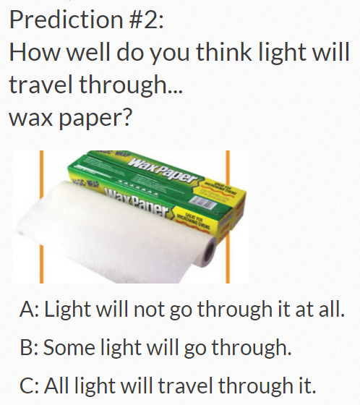
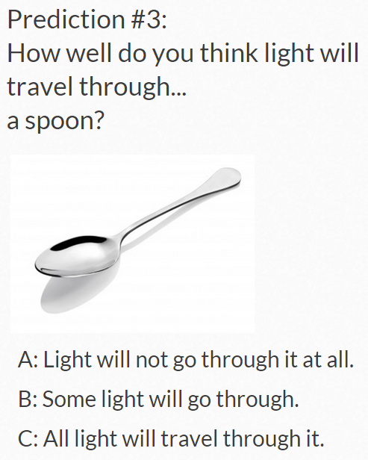 | 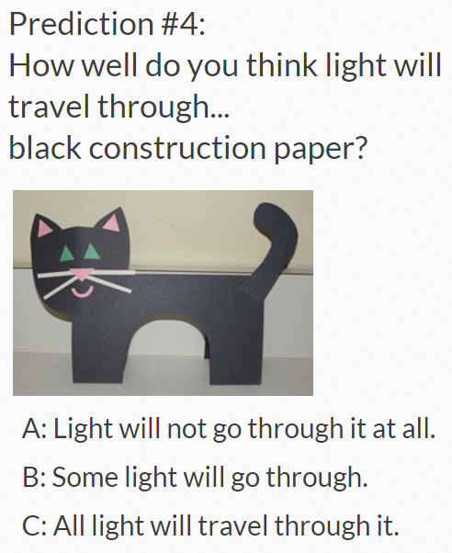 | 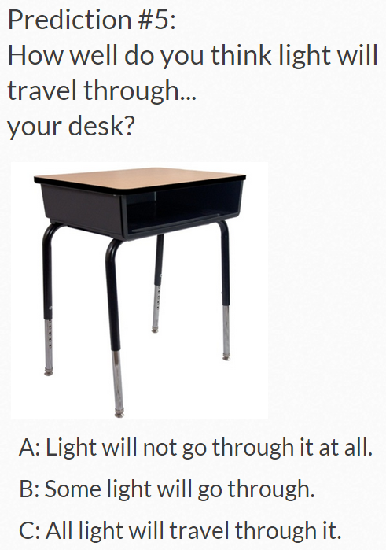

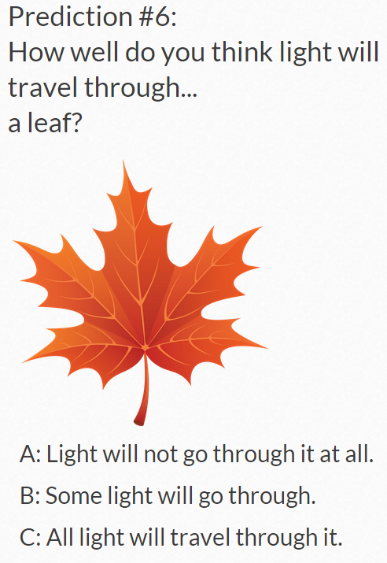 | 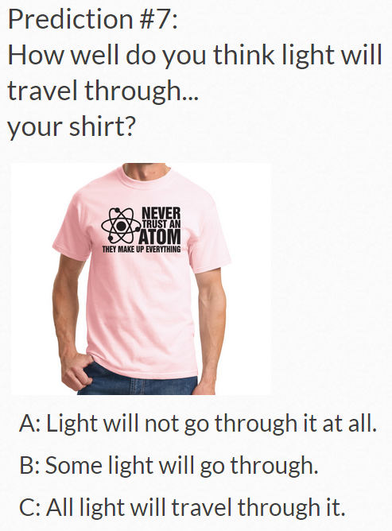 | 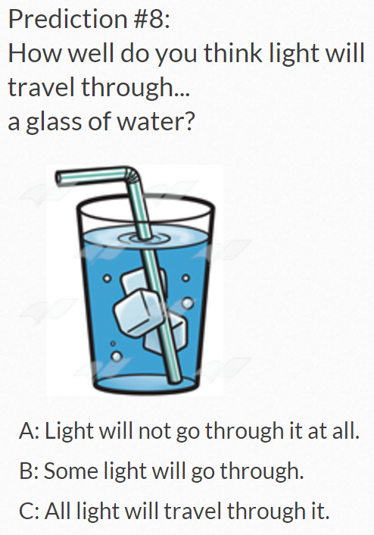
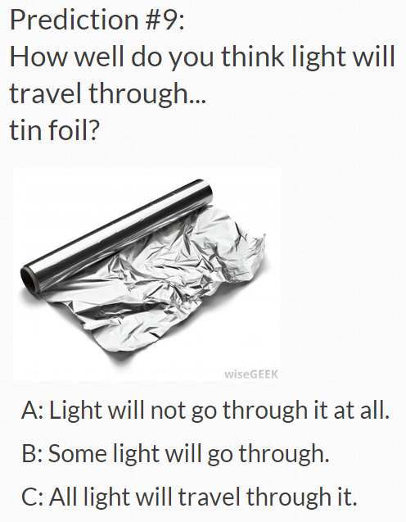 | 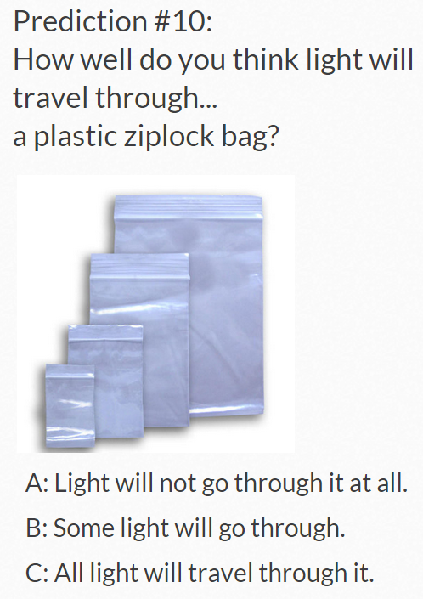 | 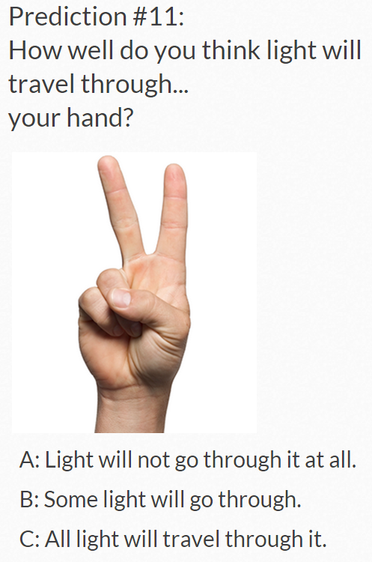

Plickers Questions  For  Object Classification  Results | 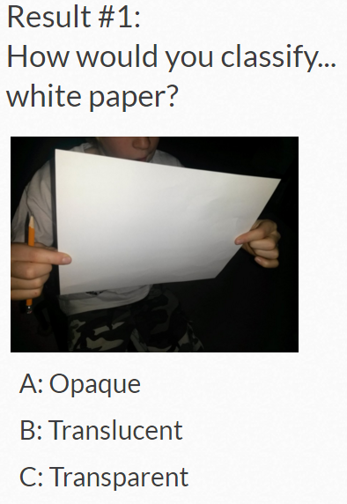 | 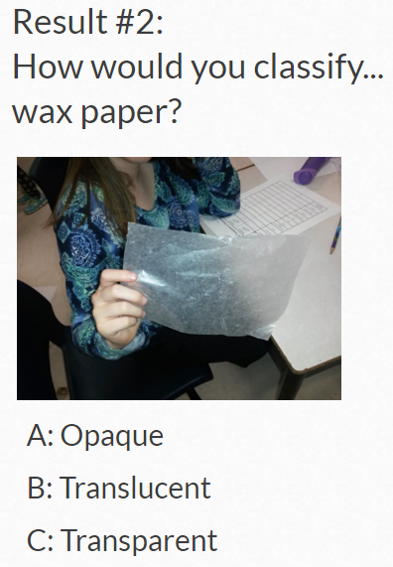
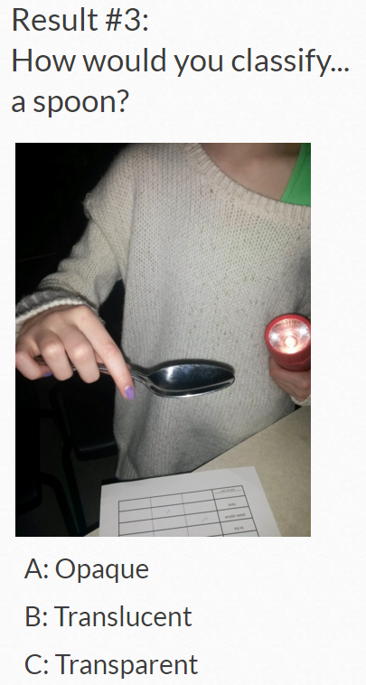 | 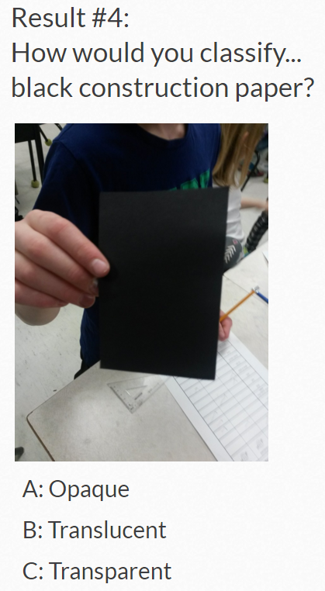 | 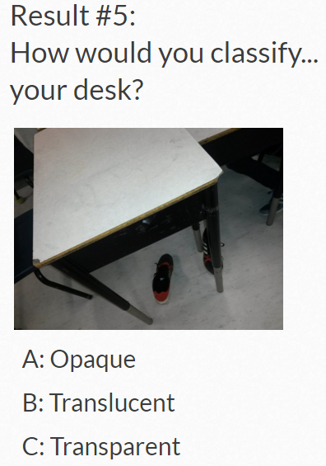

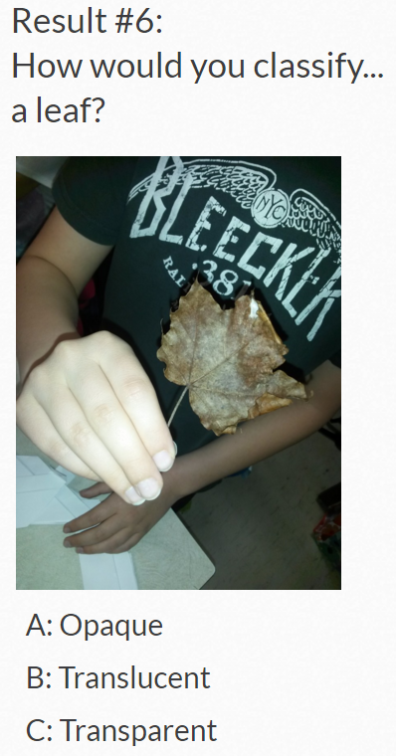 | 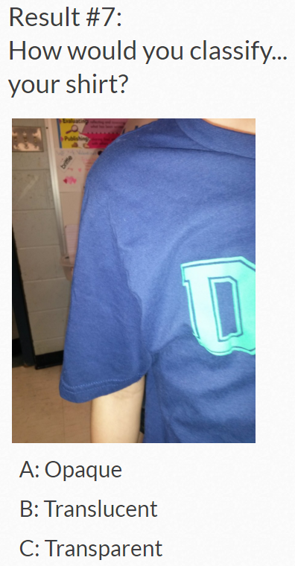 | 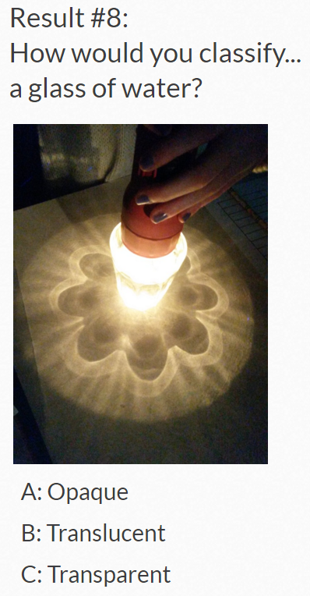
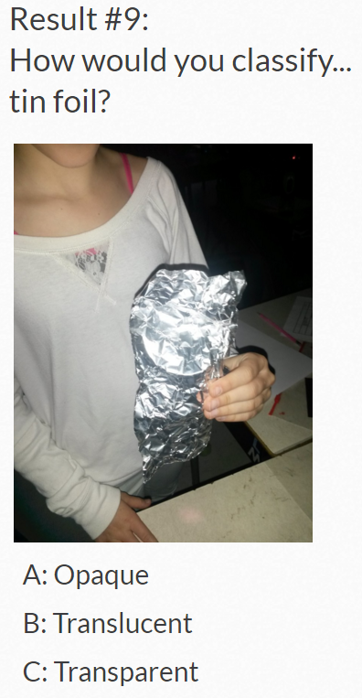 | 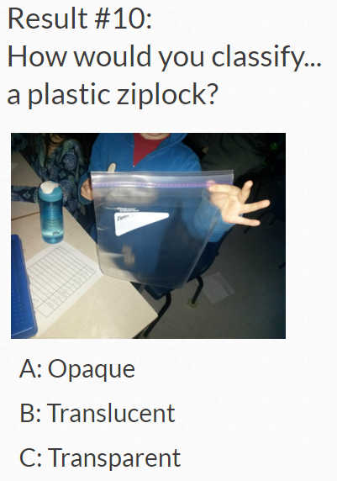 | 