Elementary Lesson Plan Template:
Grade:_4_ Subject: _Math_____ Timeframe: _60 min________
Driving Question: The class is feeling crowded during reading time on the floor so Mr. Casey would like to know if there is any other classroom in the school worth switching to. How can you find out which one he should take to have the most floor space?

Learning Targets:
- Describe area as the measure of surface recorded in square units and explain why the square is the most efficient unit for measuring area.
  - M03 Students are expected to demonstrate and understanding of area of regular and irregular 2-D shapes by
- recognizing that area is measured in square units
- selecting and justifying referents for the units cm² and m²
- estimating area using referents for cm² and m²

Resources:
- Screencast setting up driving question and show classroom layouts
- Rubrics for Communicating Ideas and Measuring Area
- Handouts of Classrooms and a sheet of squares (photocopy rubric onto back of classroom sheets)
- Spreadsheet for data (save your own copy prior to lesson)
- Screencast showing how to split up a tile for measuring area
- 5 netbooks (sharing one copy of above mentioned spreadsheet)
- 5 bins containing
  - 6 copies of one of the classrooms in handouts mentioned above
  - 6 copies of tile sheet included in handouts mentioned above
  - 2 rulers
  - Zip Locks
    - 1 containing Base-Ten rods
    - 1 containing 10 cm long pieces of string
    - 1 containing tiles
    - 1 containing pennies

Adaptations (Child Specific):
- (R.G., W.K., & H.G.) - checklist of steps

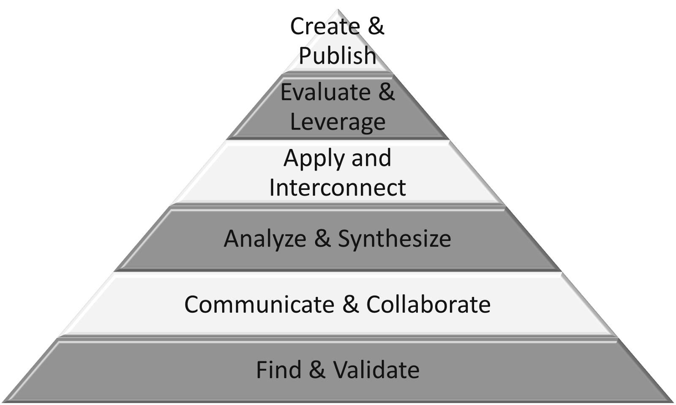
Part 1: (25 - 30 min) ✔

( ) Create & Publish
( ) Evaluate & Leverage
( ) Apply & Interconnect
(✔) Analyze & Synthesize
(✔) Communicate & Collaborate
(✔) Find & Validate

Connection
Introduction:
- show start of video
  - Intros 5 rooms and premise of which is biggest.
- Pause (see Note¹ below)

- Teacher Script:
- What do we already know about measurement?
- If I wanted to compare classrooms, what would I want to know?
- What types of things can we try to use to measure?

- Do Table-Top Blog for students to communicate how they could solve the problem of which room has the biggest space (intentionally not using the word area) (see Note² below)

- Intro 5 different tools to try measuring the space (Penny, ruler, string, Base-Ten rod, tile)

Reflecting on prior teaching:
- remind students that distance is measured by line segments and that a good form of measurement is clearly communicated and consistently accurate

(Notes:)
- pause after intro of materials (1st time doing the lesson, that will be the end of the video - the videos taken of the students’ attempts at area will be added to video for an option available for future lesson wrap ups)

- Table-Top Blog as described by Jenna Barclay in Ideas for Teaching 21st-Century Skills Without Technology:
- “Start by having each student write his or her ideas about a topic (like they would on an online blog) on a piece of notebook paper at their desk. Have students leave their piece of paper at their desk and find a new seat. At their new seat, students read the original thought on the piece of paper and then respond by commenting, asking questions, or adding to their peer’s idea. Have students rotate around until each student has multiple points of view to consider. Once students go back to their original seats, they should have many perspectives to use to refine or reinforce their original idea.”

Guided Practice
- Hand out bin with 5 different materials (pennies, tiles, Base-ten rods, string, ruler) and 5 different sheets (Classrooms 1-5). Each tool is assigned to a specific classroom (see Note below)
- Students try material to see how it could be used to communicate the area covered by the classroom they received.
- Go over rubric (found on back of sheets) that will be used to assess their ability to communicate their thinking
- They attempt to communicate their measurement and thinking in the space provided, referring to the material they used and any pros or cons they found with using it for this purpose.
- When finished, students take videos of themselves, on Ipads, explaining any pros and cons as to the usefulness of their material for measuring area

(Notes:)
- Sheets labeled Classroom 1-5 and can be fictional classrooms but for my school they are actually scaled to match specific rooms. Also, the small square tiles = 1m²
  - Pennies / Classroom #1 = Mme Joubert’s room
  - Ruler / Classroom #2 = Ms. Grant’s room
  - String / Classroom #3 = M. Aucoin’s room
  - Base-Ten Rods / Classroom #4 = Mr. Casey’s room
  - Tiles / Classroom #5 = Mme. Sydney’s room

Explicit Teaching Teacher models/demonstrates
- acknowledge how students with the same Classroom and material may have come up with different ways of using the tool and therefore, different measurements.
- Use the Air Server option on the IPads to share a few videos with the class as to how different students used different material and how the square tiles appeared to be most consistent

Part 2: (15 - 20 min) ✔
(✔) Create & Publish
(✔) Evaluate & Leverage
(✔) Apply & Interconnect
( ) Analyze & Synthesize
( ) Communicate & Collaborate
( ) Find & Validate

Independent/Groups
Practice/Conference focus:
- everyone returns to their sheet and uses tiles (paper squares) to determine the area of their classroom
- tell them to glue the paper squares onto their sheet and try to get as accurate as they can
  - discuss what they could do if a square overlaps the edge and then show screencast
    - cut that piece off but mark both pieces with the same letter (ex. A) and then try to use that piece somewhere else that won’t fit a full square.
- they then count the number of squares they fit in the classroom (only counting the cut up pieces with the same letter on them, as 1)
- they write out answer on sheet (as total area = ____ squares) and then post on spreadsheet table found on group’s netbook

Part 3: 5-10 minutes

(✔) Create & Publish
(✔) Evaluate & Leverage
(✔) Apply & Interconnect
(✔) Analyze & Synthesize
( ) Communicate & Collaborate
( ) Find & Validate
Time to Share
- discuss how each square was made to equal 1 m² in real life and therefore, their measurement of the areas of each classroom were in m²
- show the data results on the spreadsheet
  - have students point out what the data on the graph represents
  - where did the numbers come from that are posted on the graph? (average)
  - why might an average be beneficial over just taking the data from one student?
- Have students communicate what they have noticed about the “area” of each classroom while speaking of the measured m² for each classroom and whether they feel a move (if sanctioned by the office) would be worth doing.
      - (could acknowledge other factors that would come into the real life decision of which classrooms work best for the specific teachers involved)

Resources

Barclay, J. (2013, September 10). No More Excuses: Teaching 21st-Century Skills in a Low-Tech Setting. Retrieved January 18, 2016, from http://www.edweek.org/tm/articles/2013/09/10/fp_barclay_skills.html

Meyer, D. (2010, May 13). Dan Meyer: Math class needs a makeover (Ted Talk). Retrieved January 18, 2016, from https://youtu.be/NWUFjb8w9Ps

Kim, S.-i. (1999), Causal bridging inference: A cause of story interestingness. British Journal of Psychology, 90: 57–71. doi: 10.1348/000712699161260

