Elementary Lesson Plan Template:
(Click here for online form version)
Grade:_____ Subject: _____ Timeframe: __________
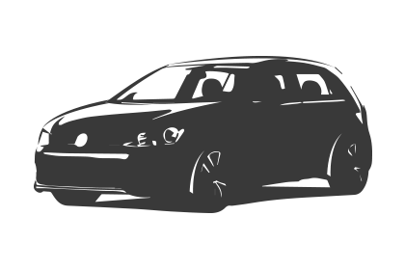Driving Question: ________________________________ _______________________________________________
Learning Targets:

Connection to school improvement

Resources: Provide links to needed online resources, screencasts, files, rubrics, assessments etc.

Adaptations (Child Specific):

Part 1: (usually 10 - 15 minutes maximum)
Identify the 21C skills that are being used in this section: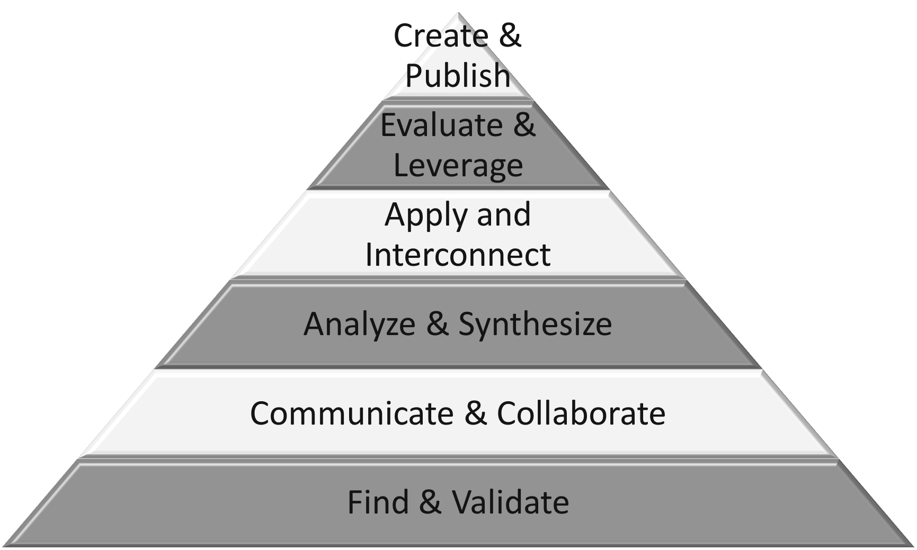
Connection  Introduction:  reflecting on prior teaching  accessing our individual prior knowledge | Teacher Script:  Yesterday we talked about…  What do we already know about…
(Notes:)

Explicit Teaching Teacher models/demonstrates  What is my purpose considering the needs of my students? | Teacher Script:  Watch me as I…  I want you to notice how I…
(Notes:)

Guided Practice  How will students participate and practice what they have just learned? | Teacher Script:  Turn and talk to your partner about…  Go into your notebook and…  Work with a partner and…
(Notes:)

Part 2: Should be the largest portion of the lesson.
Identify which 21C skills are being used in this section:
Independent/Groups  Practice/Conference focus:  Name the skill/strategy from the explicit teaching.  Students try it independently | Teacher Script:  Today and every day…  When working today, use this strategy when…  When working today, remember…
(Notes:)

Part 3: 10-15 minutes*
Identify which 21C skills are being used in this section:
Time to Share  Will I use share time as…  -a mini-lesson reinforcement?  -a problem solving opportunity  -an opportunity for descriptive feedback  -an opportunity for assessment  What will it look like?  - Whole class  - Partner  - Small group | Teacher Script:  - Something I noticed today…  - Today we learned…  - Student name will share his/her learning….  - Student name will share a connection to his/her learning…  - One thing I’d like you to talk with your partner about while you share…  - While you are sharing, I will be looking for…
(Notes:)

21st Century Skills:

summary of all 21C skills are being used in this lesson:

Next Steps: (Include parts or portions of the lesson that are not complete.)

Reflections: How did the lesson go? What went well? What should I change next time?

