Grade:_4_ Subject: Lang. Arts Time-frame: _60 minutes________
Click here for online copy found at mrcaseyhrsb.weebly.com

Class Rules: Gotta Present’em All!
(Lesson #8 from PBL: Who Am I?)
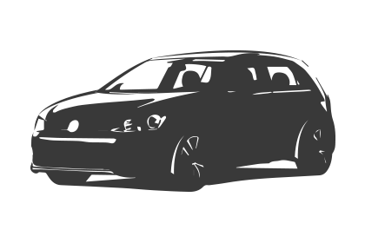Driving Question: Where were all the rules that were hiding around the classroom and where were their hiding places?

Learning Targets:
- Language Arts
  - Outcome 7: Writing and other Ways of Representing
    - Students will be expected to use writing and other representations to explore, clarify and reflect upon thoughts and experiences.
- Technology
  - Outcome 3: Communication
    - Students will use digital tools to communicate and work collaboratively, including at a distance, to support individual learning and to contribute to the learning of others.

Resources:
- LCD Projector
- Screencast on Gotta Catch’em All
- School IPads
- (Optional: If students brought their own device for previous lesson, they need to have saved it to their Google Drive.)
- Completed Student Handouts
- Teacher Copy of Rules
- Paper with record of device sign-out
- Google Slide prepared for Classroom Rules
- A special AR image needs to be prepared,
    - Take a photo of the Class Me to We Image made on Day 2 of the PBL
    - Using Aurasma,
      - take a picture of the classroom door
      - Make an Augmented Reality image with the Classroom door as the trigger and the Me toWe image as the overlay
      - When viewing the classroom door, the door should transform into the Me to We image using AR

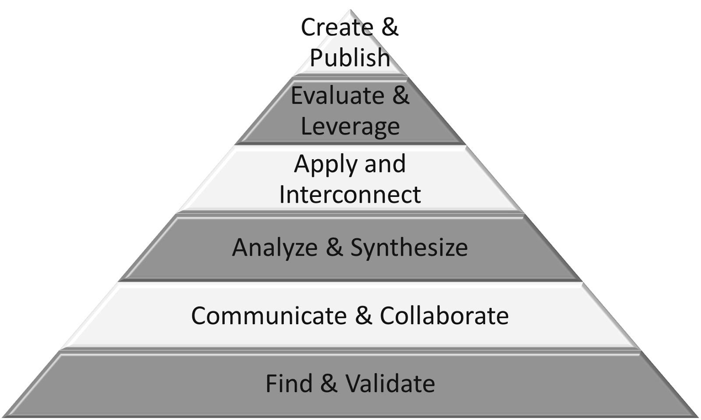
Part 1: (20 - 25 min) ✔

( ) Create & Publish
( ) Evaluate & Leverage
( ) Apply & Interconnect
(✔) Analyze & Synthesize
(✔) Communicate & Collaborate
(✔) Find & Validate

Connection

- Remind students of how the rules were hidden all aroud the classroom but each has a hidden purpose (just as these had hidden Class Dojo monsters)
- sometimes the reason may not be evident, or easy to discover, but it will be there and is there for one major purpose, to help you

Guided Practice

- Have and iPad on Air Server broadcasting to the LCD projector while logged into Aurasma
- Inform the students that there is still one hidden rule that was not found
- Pick a volunteer to take the iPad and venture into the hallway, close the door and look back at the classroom
- The door should transform into the Me to We image
- Direct the student to take a picture of this AR image just like they had done the day before

Explicit Teaching Teacher models/demonstrates
- Replay Screencast on Gotta Catch’em All
- direct student attention to the latter part of the video where the Google Slide is mentioned
- Demonstrate for the students how to do their next task
- Through Google Classroom,
  - open Google Slide of Classroom Rules
  - Follow the directions on the slide to add the snapped image of the AR door
  - demonstrate how to manipulate the photo to fit in properly
  - Click on the text box and change the text to the following
    - “We respect each other and ourselves!”
  - Remind them that ‘each other’ refers to all of us on this planet together

Part 2: (15 - 20 min) ✔
( ) Create & Publish
( ) Evaluate & Leverage
(✔) Apply & Interconnect
(✔) Analyze & Synthesize
(✔) Communicate & Collaborate
( ) Find & Validate

Independent/Groups

- Students return to their own devices and working collaboratively or independently,
  - They log onto Google Classroom
  - Find the slide with their Rule # on it
  - Embed the AR image taken in last class
  - Type the rule into the upper left text box

Part 3: 5-10 minutes

(✔) Create & Publish
(✔) Evaluate & Leverage
( ) Apply & Interconnect
( ) Analyze & Synthesize
( ) Communicate & Collaborate
( ) Find & Validate
Time to Share
- post the slide as an embeded document onto the class website
- view one last time as a class, reviewing why each rule is there

