Grade:_4_ Subject: Lang. Arts Time-frame: _60 minutes________
Click here for online copy found at mrcaseyhrsb.weebly.com

Class Rules: Gotta Catch’em All!
(Lesson #7 from PBL: Who Am I?)
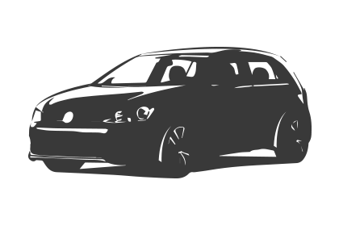Driving Question: What rules are hiding around the classroom that need to be caught and brought out into the light?

Learning Targets:
- Language Arts
  - Outcome 7: Writing and other Ways of Representing
    - Students will be expected to use writing and other representations to explore, clarify and reflect upon thoughts and experiences.
- Technology
  - Outcome 3: Communication
    - Students will use digital tools to communicate and work collaboratively, including at a distance, to support individual learning and to contribute to the learning of others.

Resources:
- LCD Projector
- Screencast on using Aurasma and Guided Access
  - (watch video and set up each device prior to class, with Aurasma and Guided Access)
- Screencast on Gotta Catch’em All
- School IPads
- (Optional: Bring Your Own Device - logged into Aurasma and teacher’s channel)
- Student Handout
- Teacher Copy of Rules
- Paper to record device sign-out

Adaptations:
- printout of the Step-By-Step Directions
    - Check in to ensure they are properly participating with their partners

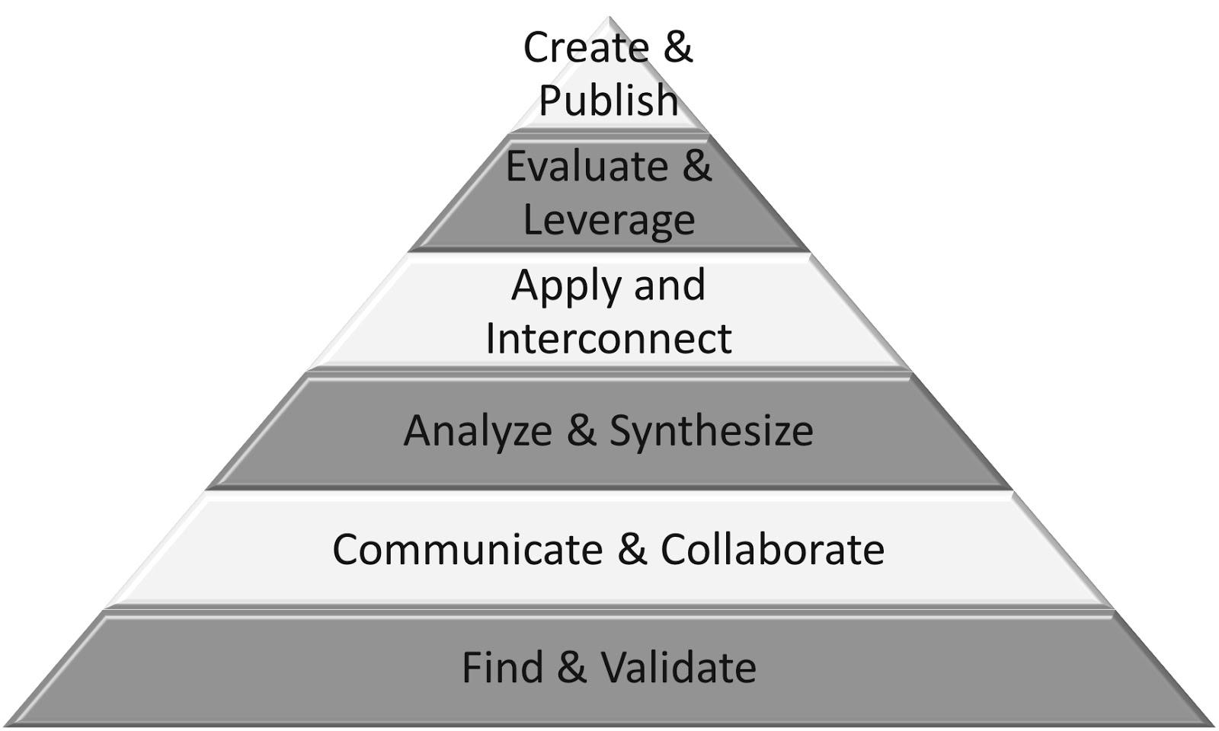
Part 1: (20 - 25 min) ✔

( ) Create & Publish
( ) Evaluate & Leverage
( ) Apply & Interconnect
(✔) Analyze & Synthesize
(✔) Communicate & Collaborate
(✔) Find & Validate

Connection
- Start by getting students to think beyond the surface. With classroom rules there must be an understanding of why they are in place, not simply what they are.
- Connect to Pokémon Go by asking them how they believe it works
  - Trigger = GPS location
  - Overlay = Pokémon character
- Today they are going to use images around the room as triggers and the overlay will be their Class Dojo monster.
- The trigger image will reference a class rule and just as there is usually a reason behind every rule, there is a hidden Class Dojo monster with every listed rule.

Guided Practice
- Students share some potential classroom rules and give possible reasons for why we should follow each of them
- Write responses on the board, highlighting the ‘why’ component

Explicit Teaching Teacher models/demonstrates
- Show screencast on Gotta Catch’em All

Part 2: (15 - 20 min) ✔
( ) Create & Publish
( ) Evaluate & Leverage
(✔) Apply & Interconnect
(✔) Analyze & Synthesize
(✔) Communicate & Collaborate
( ) Find & Validate

Independent/Groups

- Handout Student Sheets
- Log into class account on Class Dojo to display all students’ Dojo monsters with their names attached
- Students fill out their name on the handout as ‘Trainer’ and look at the board to find out what their Class Dojo monster (referred to as a starter Casémon instead of starter Pokémon) looks like.
- They then write the number of their starter Casémon monster, as shown on their handout, in the spot on the top right corner of their page as Student #.
- The associated class rule for their starter Casémon is a hint for where to look for it in the classroom.
- Students take their Casédex (Ipad or other device already locked on Aurasma) and search for their Casémon. (Have students sign out devices so that you have a list of which student has which specific device number.)
- When they find it, they position the Casédex (device) to get a clear image and then use the app to take a picture showing the Casémon with the associated rule’s image.
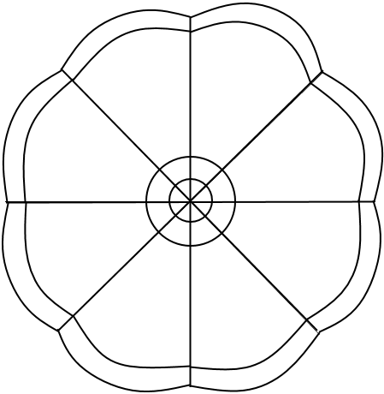
- They then colour in their Caséball (Pokéball) on their sheet to show that it has been captured.
- Students then go searching for the others in the class, using the other Casémon Trainers to help find the remaining Casémon.
Part 3: 5-10 minutes

( ) Create & Publish
(✔) Evaluate & Leverage
(✔) Apply & Interconnect
( ) Analyze & Synthesize
( ) Communicate & Collaborate
( ) Find & Validate
Time to Share
- Students return devices and share their stories from the search
- Return each description of a found character to a discussion of the rule that connects to it and potential reasons for the rule

Trainer:_______________

Student # ___

- Day 1
  - Use the rule as a hint to catch the creature hidden in the classroom
  - Check off any that you caught
  - When you find the character with your Student #, snap an AR picture of it showing it hiding in its spot.
- Day 2
  - Go to Google Classroom and click on the “Gotta Catch’em All!” Google Slide assignment
  - Find your Slide with your Rule # (ex, Student #4 is Rule #4)

Always ask permission before using the computer.  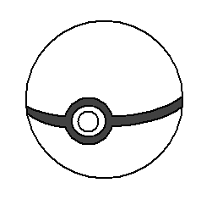 | 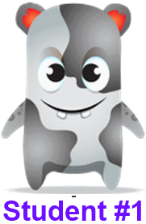 | Always be a good Digital Citizen. | 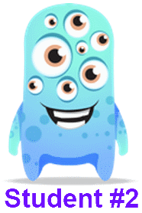
Keep all four legs of your chair on the ground. | 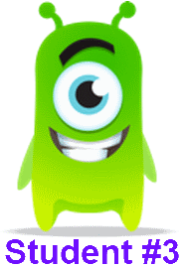 | Ask permission before using the Smart Board. | 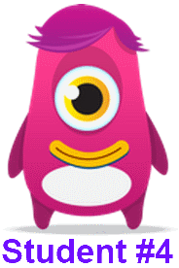
Ask permission before you print any material. | 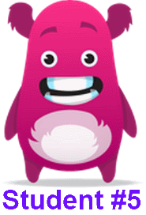 | Return all Smart Board pens to the correct place. | 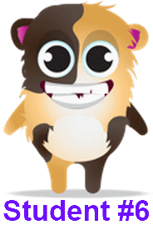
Double check you are not printing more pages than you need. | 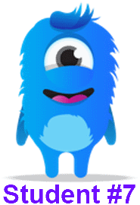 | Don’t be afraid to make mistakes. | 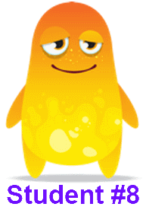
Keep hand away from electrical sockets. | 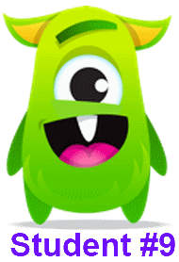 | Put all food waste in the compost bin. | 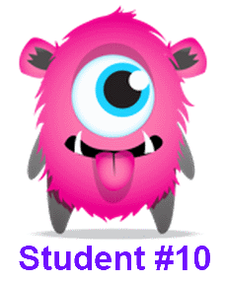
Make sure no garbage is left on the floor. | 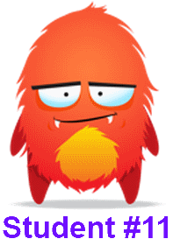 | Reduce the amount of paper that you use. | 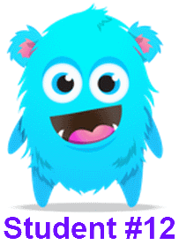
Hands are kept off the thermostat. | 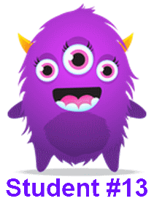 | The classroom door is to remain open when a teacher is not in the class. | 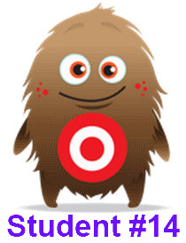
Ask the teacher for help whenever needed. | 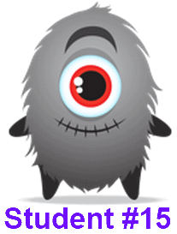 | Be sure to turn off your computer when finished. | 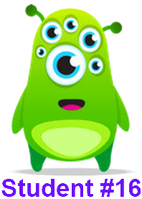
Ask permission before touching the curtains. | 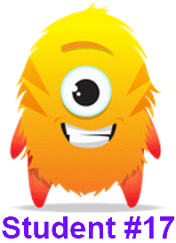 | Turn the lights off if you are the last one leaving the room. | 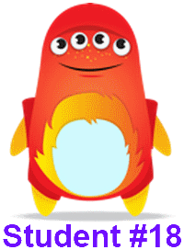
Follow fire drill directions calmly. | 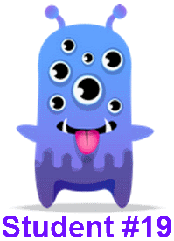 | Always remember who is in charge. :) | 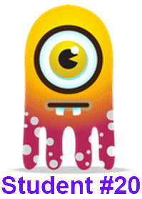

Teacher Copy: Sample Version only - Real one needs to be set to classroom in Sept.
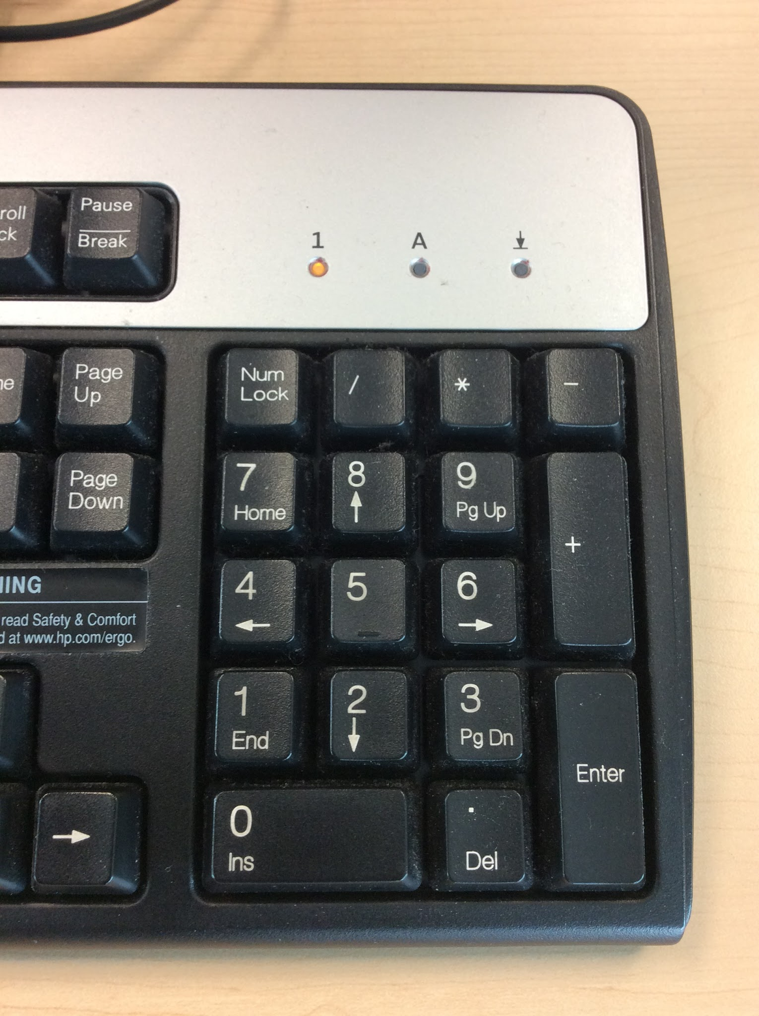Always ask permission before using the computer. |  | 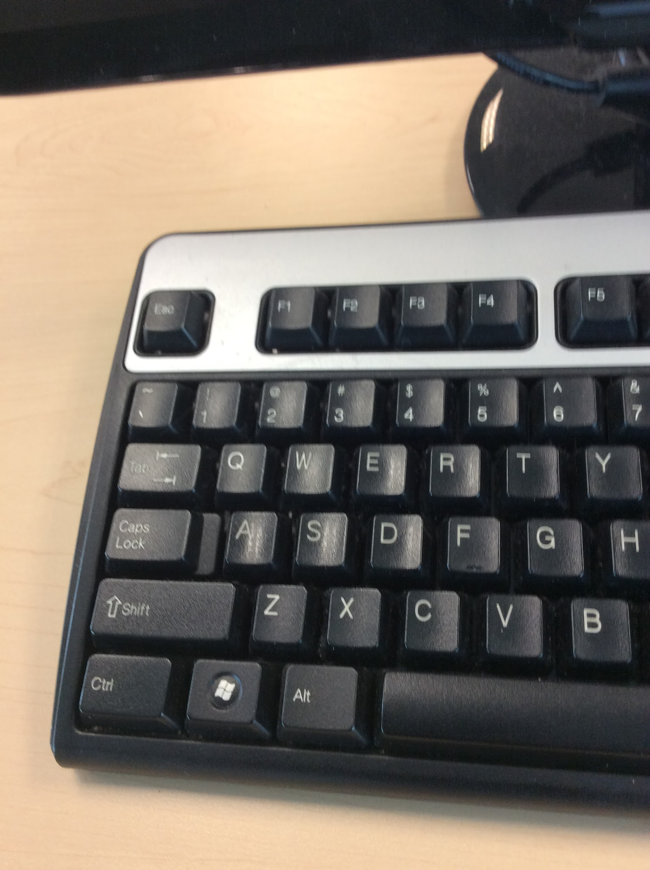Always be a good Digital Citizen.
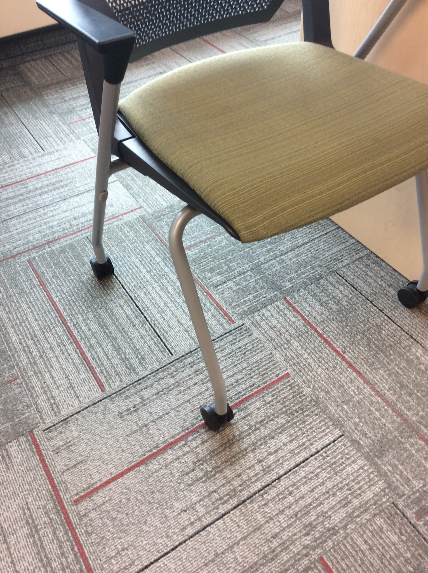Keep all four legs of your chair on the ground. |  | 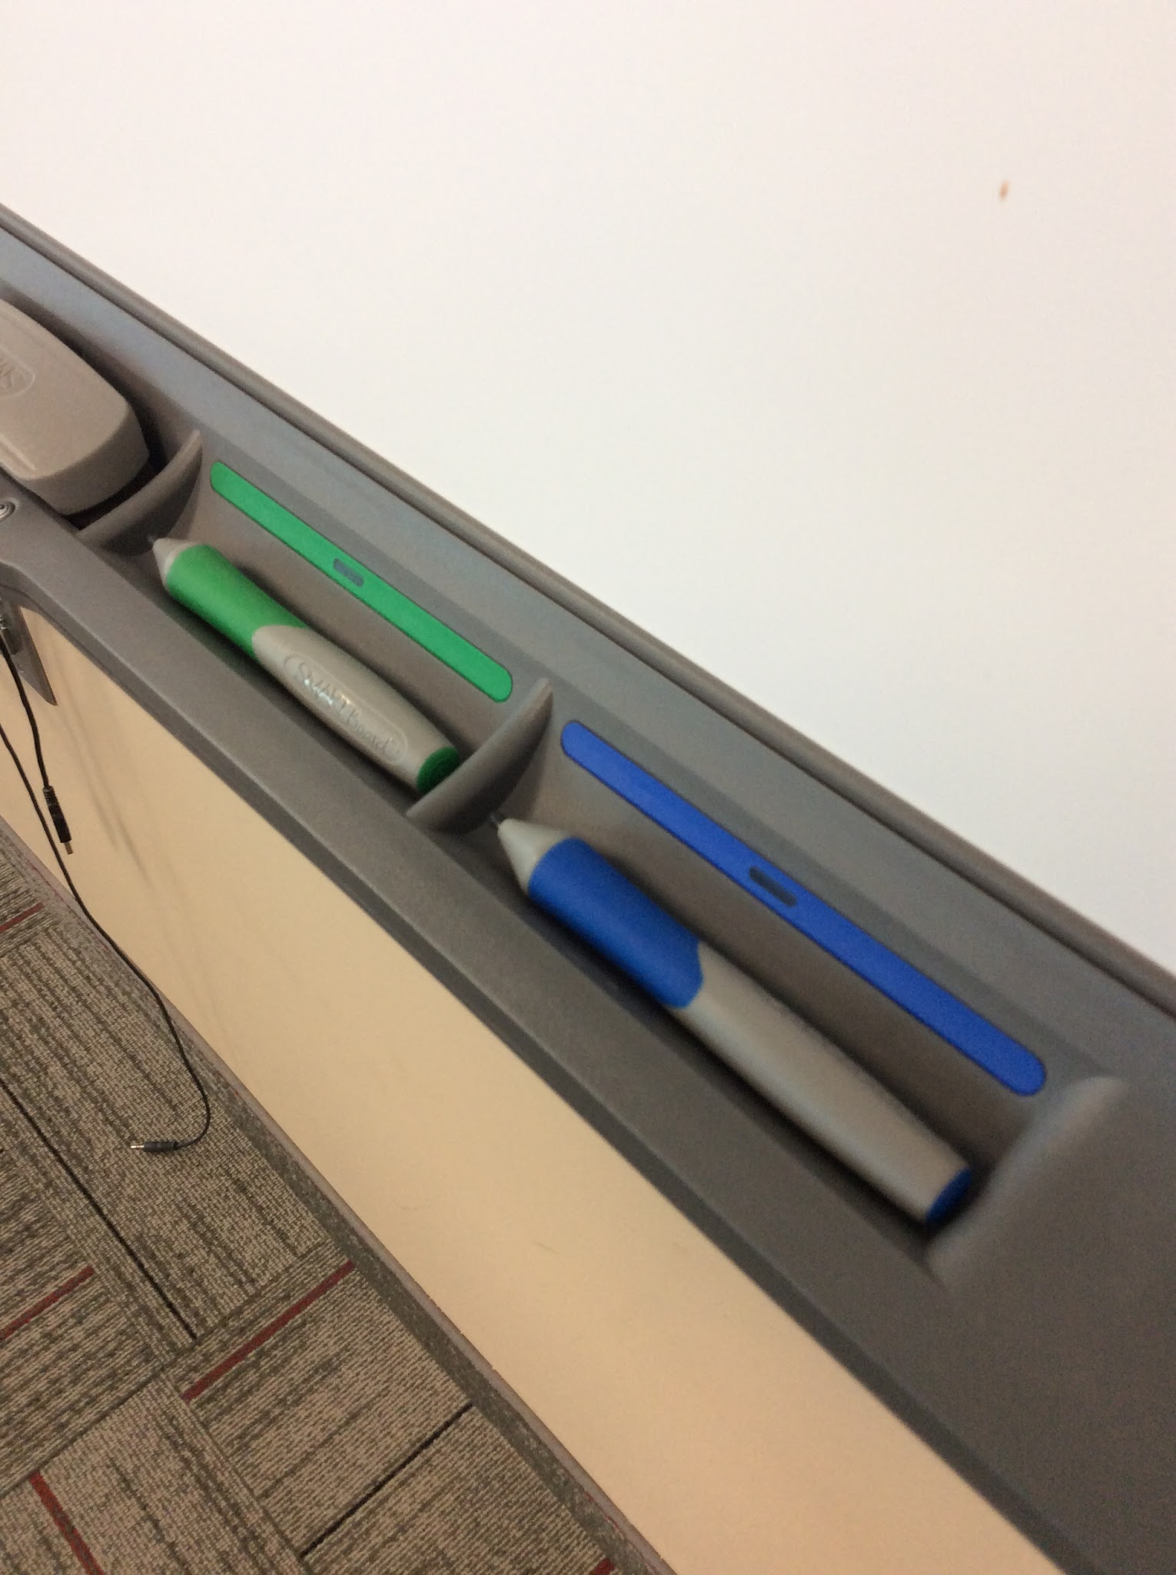Ask permission before using the Smart Board.
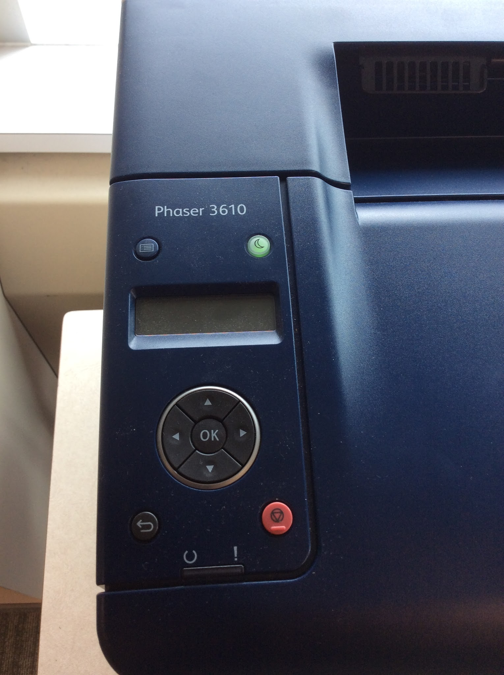Ask permission before you print any material. |  | 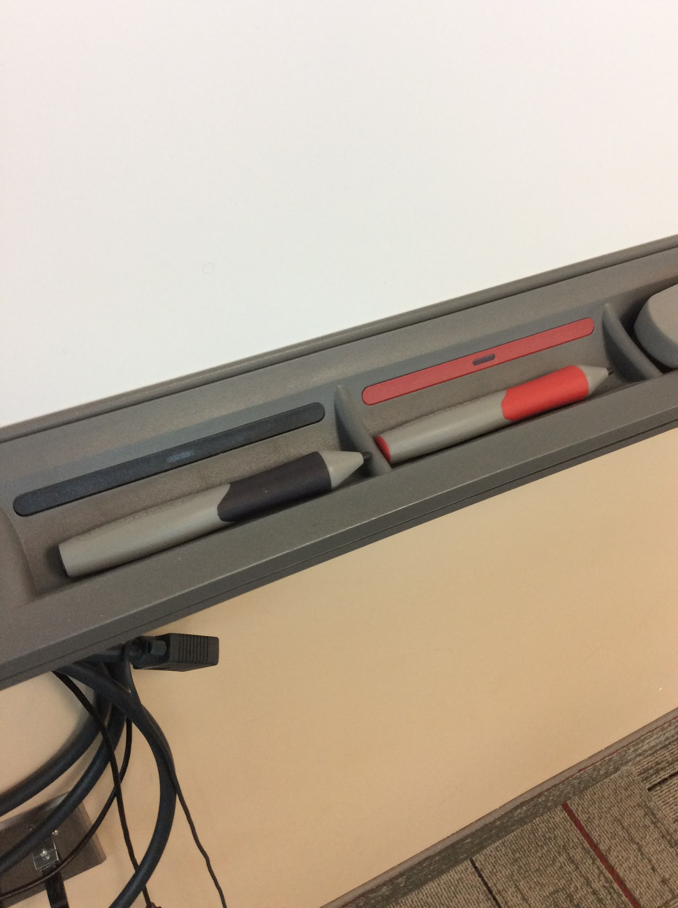Return all Smart Board pens to the correct place.
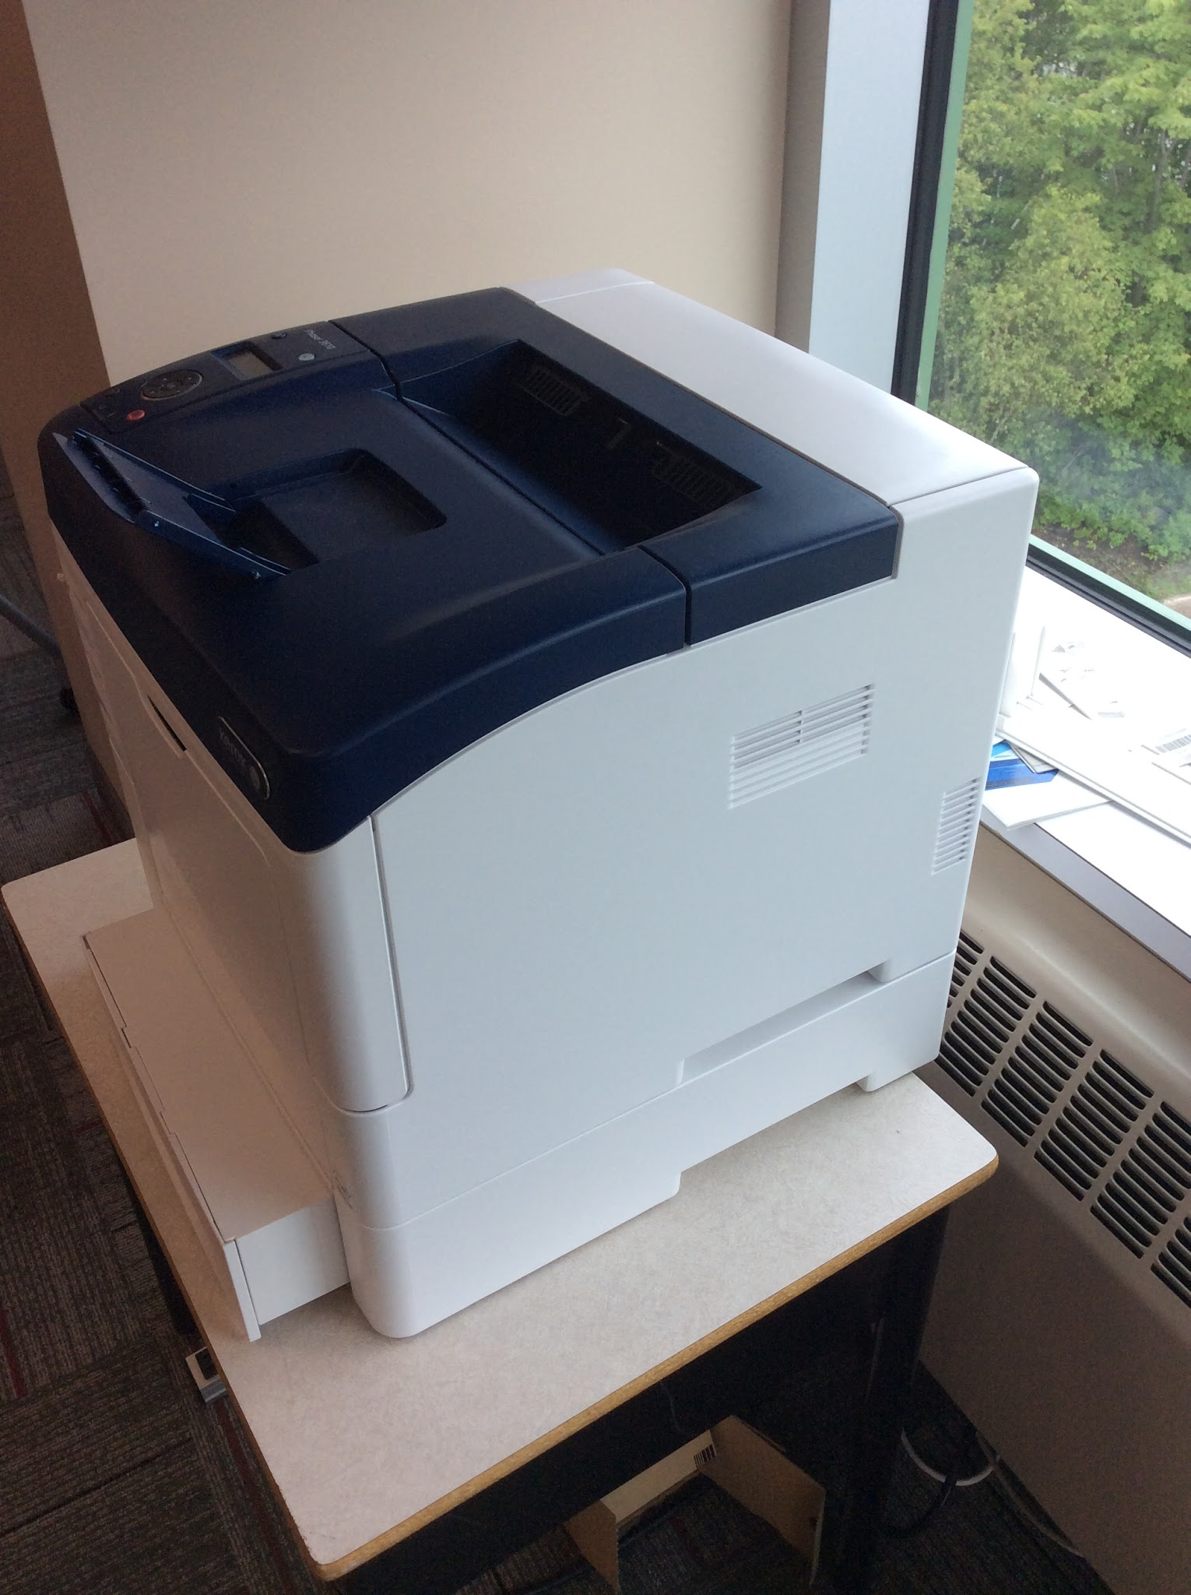Double check you are not printing more pages than you need. |  | 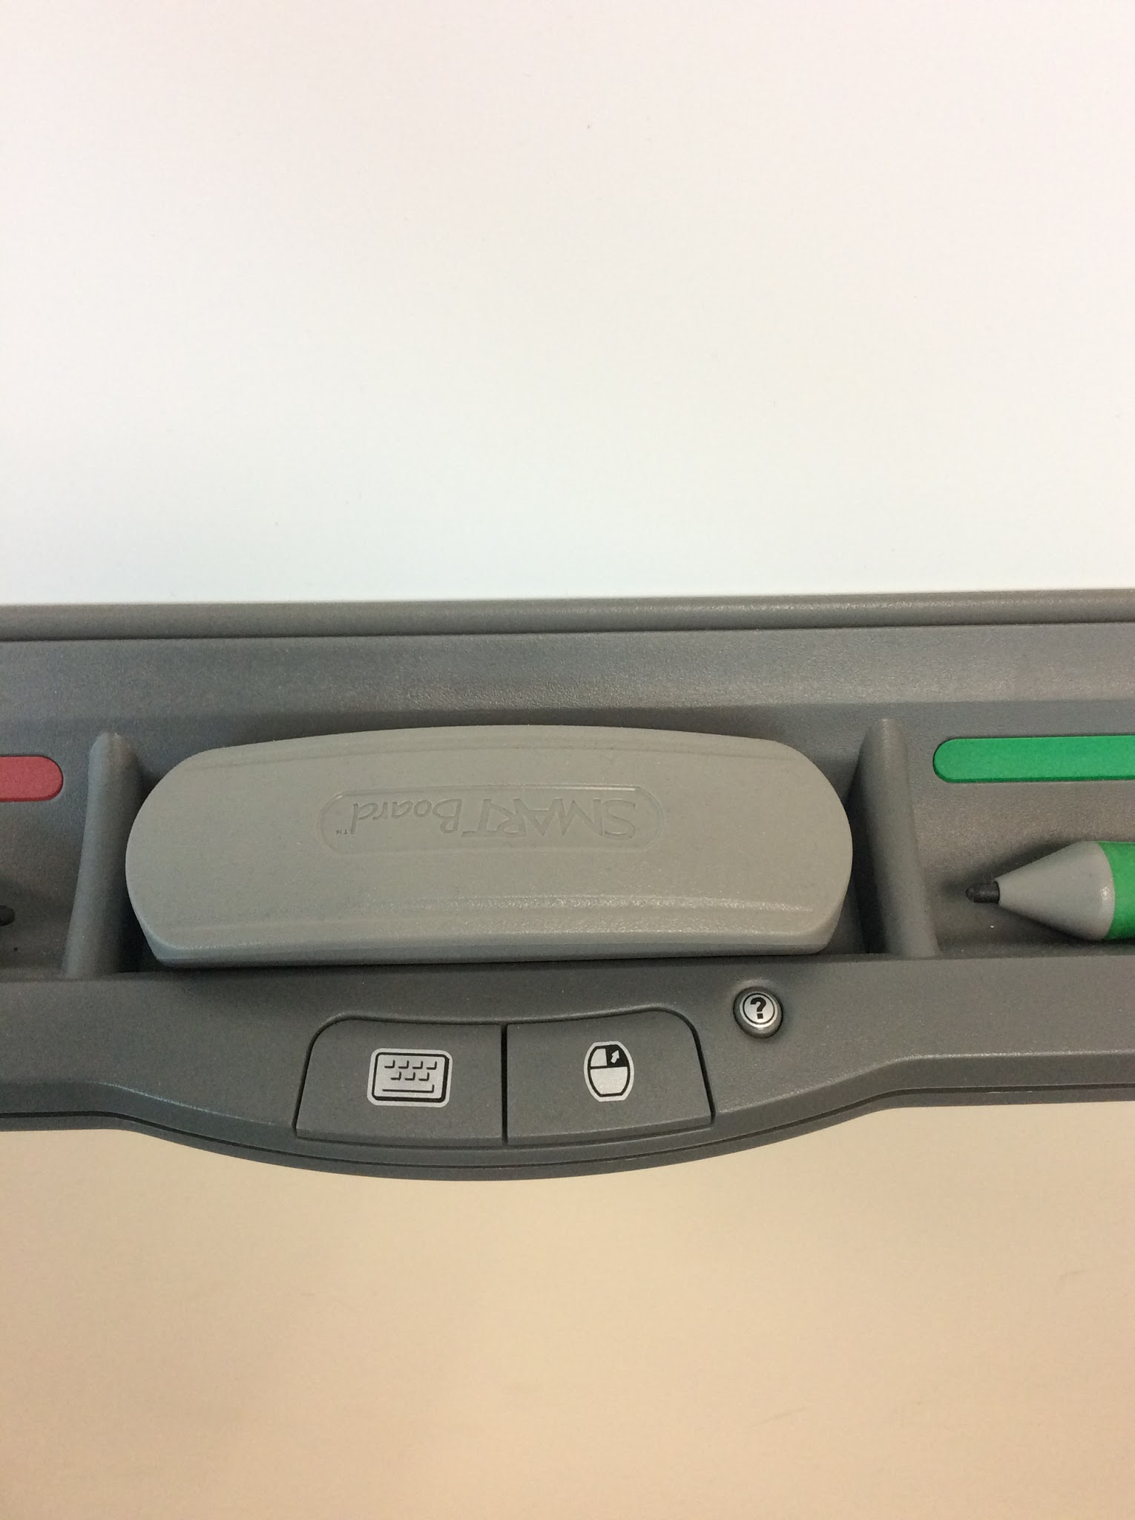Don’t be afraid to make mistakes.
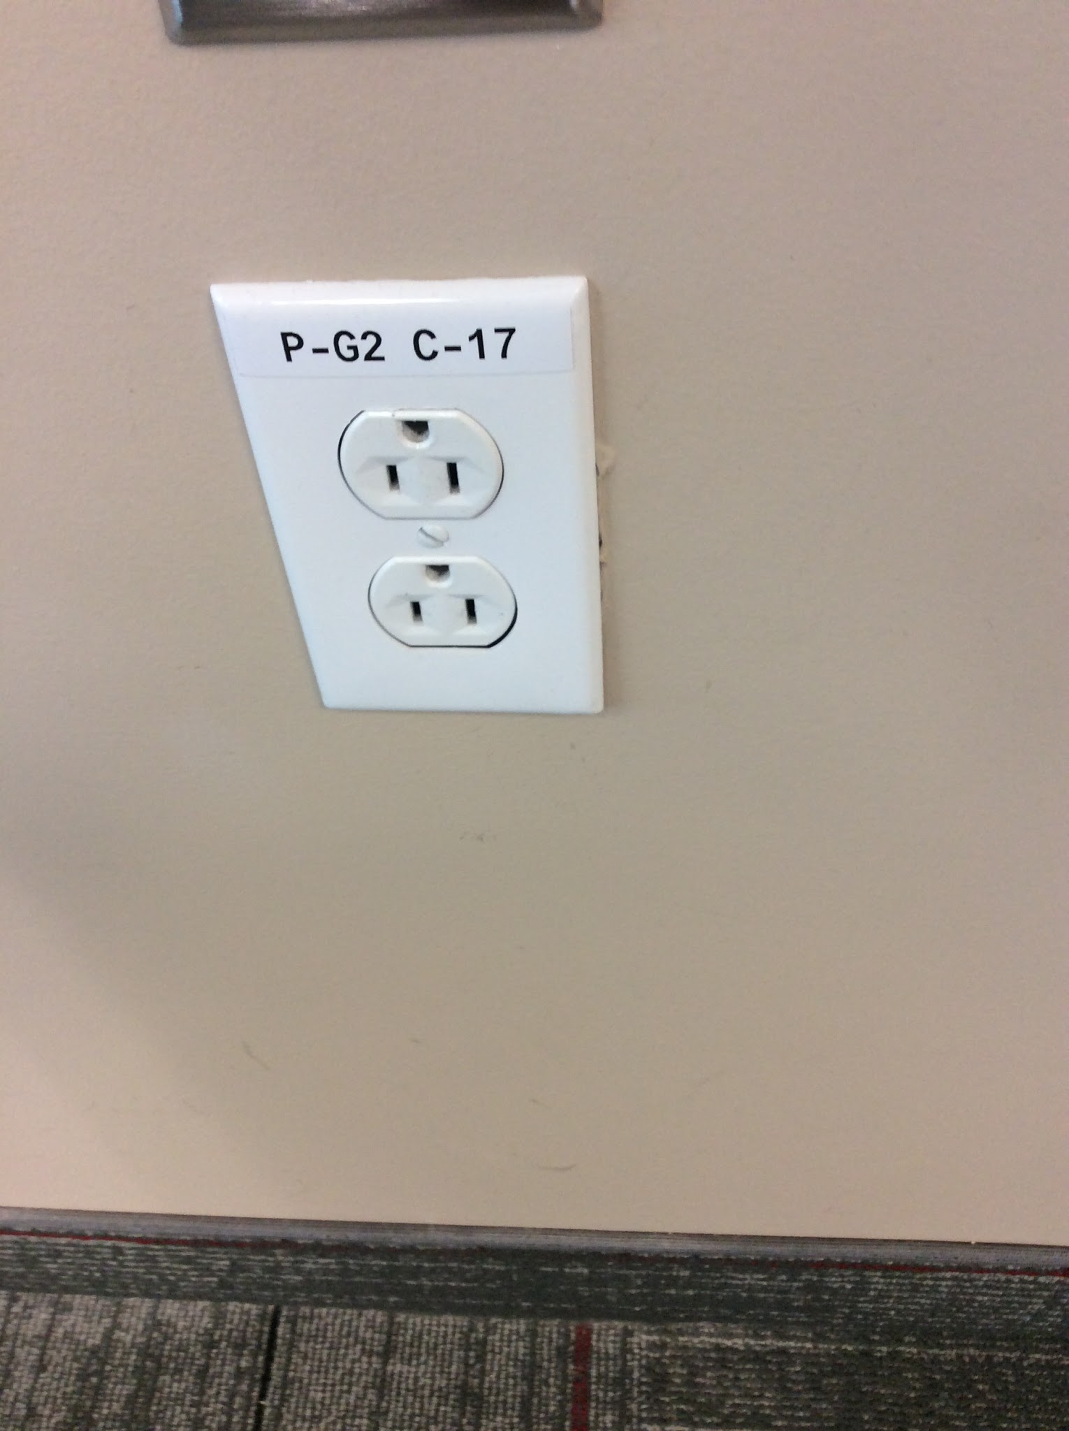Keep hand away from electrical sockets. |  | 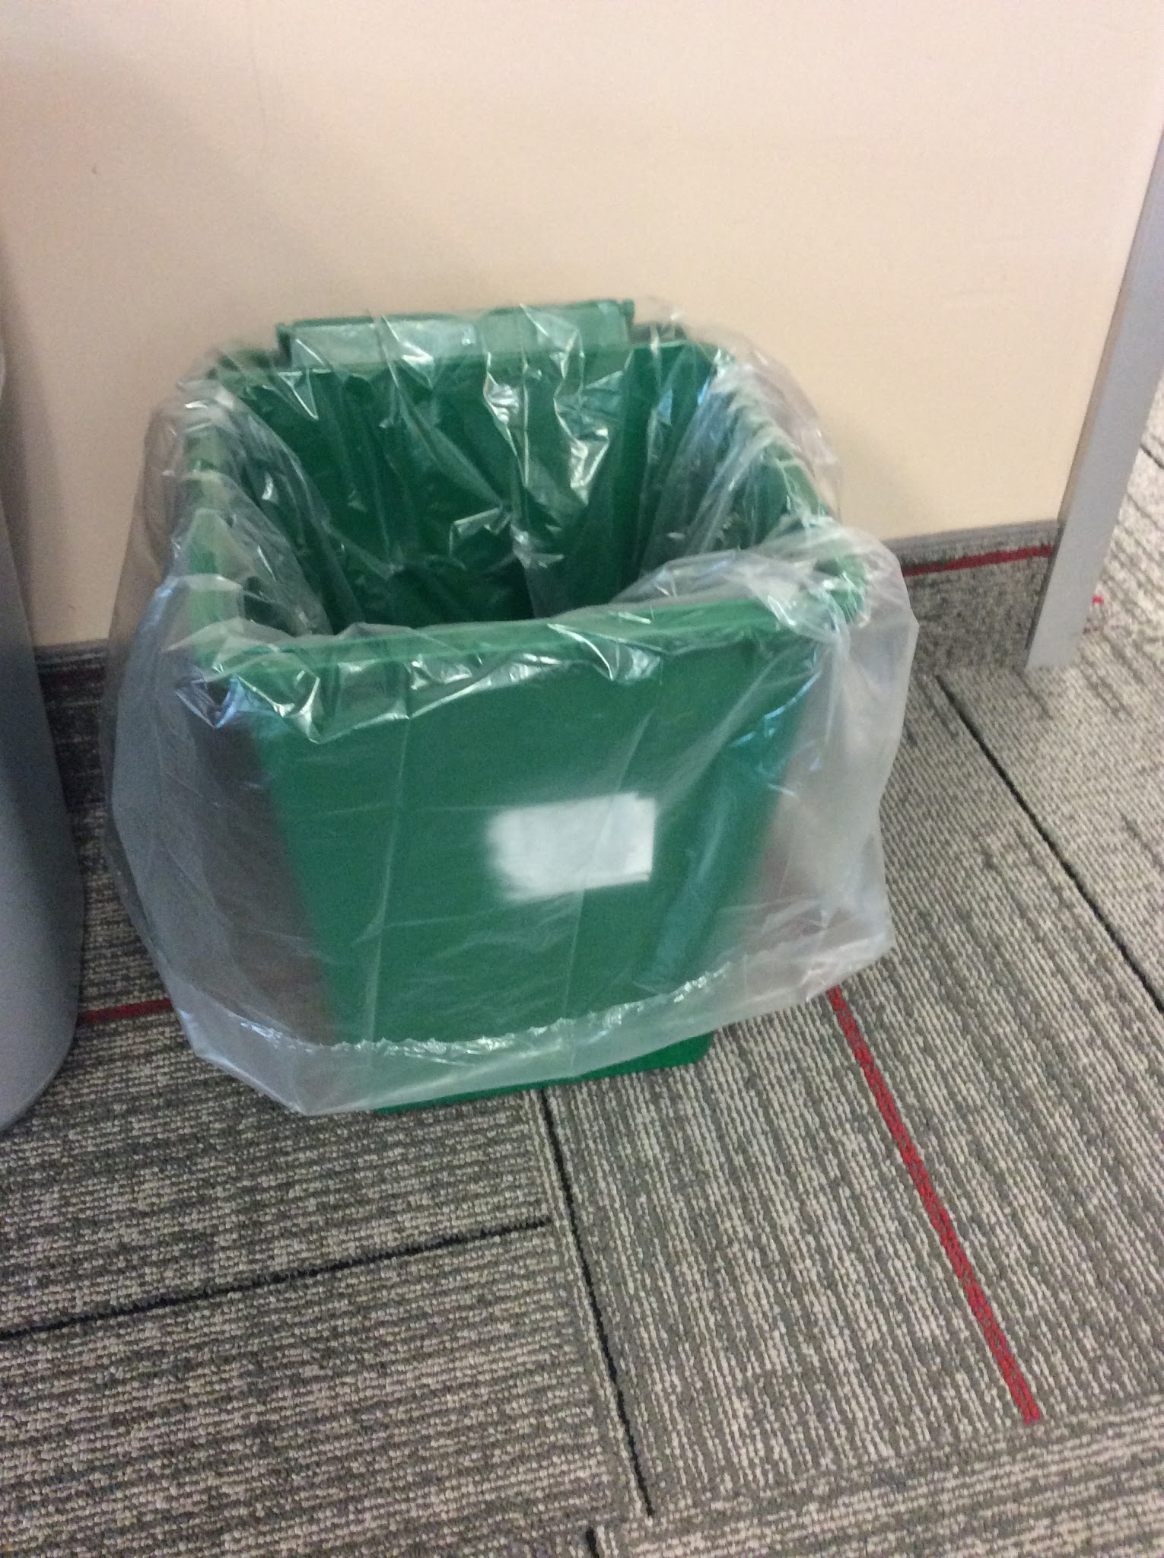Put all food waste in the compost bin.
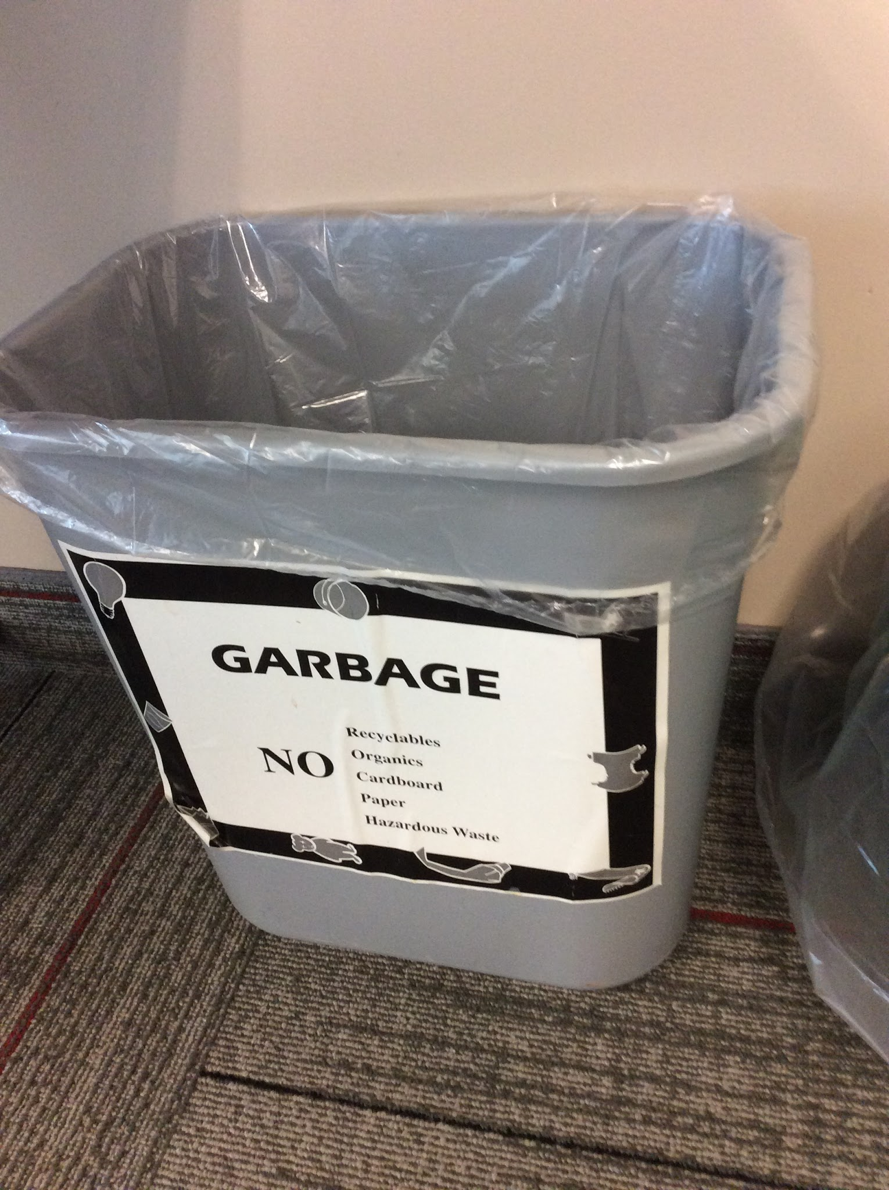Make sure no garbage is left on the floor. |  | 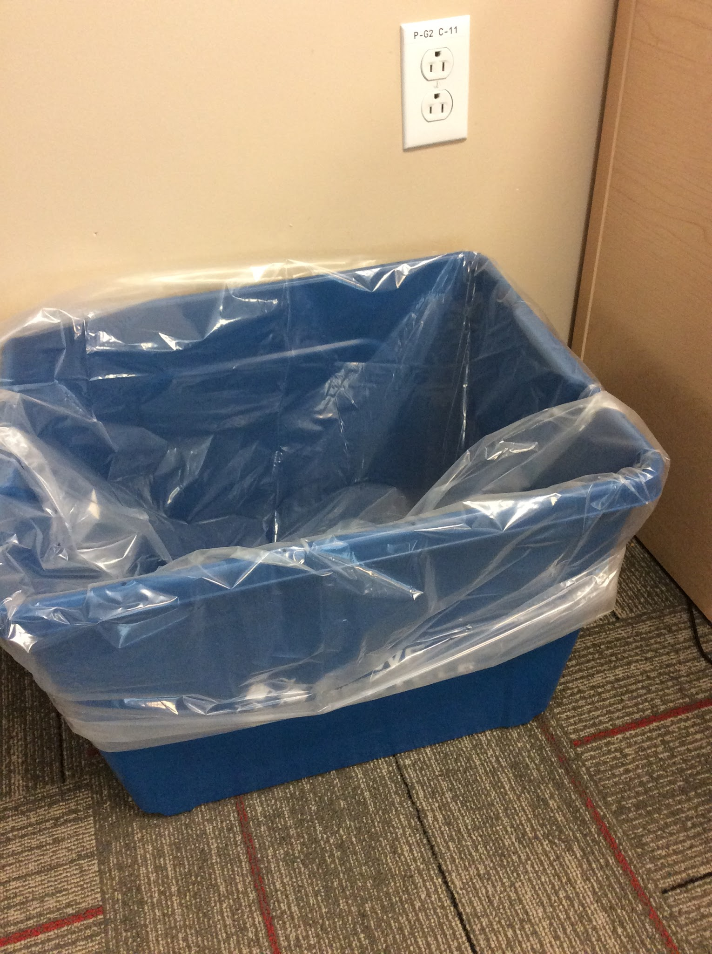Reduce the amount of paper that you use.
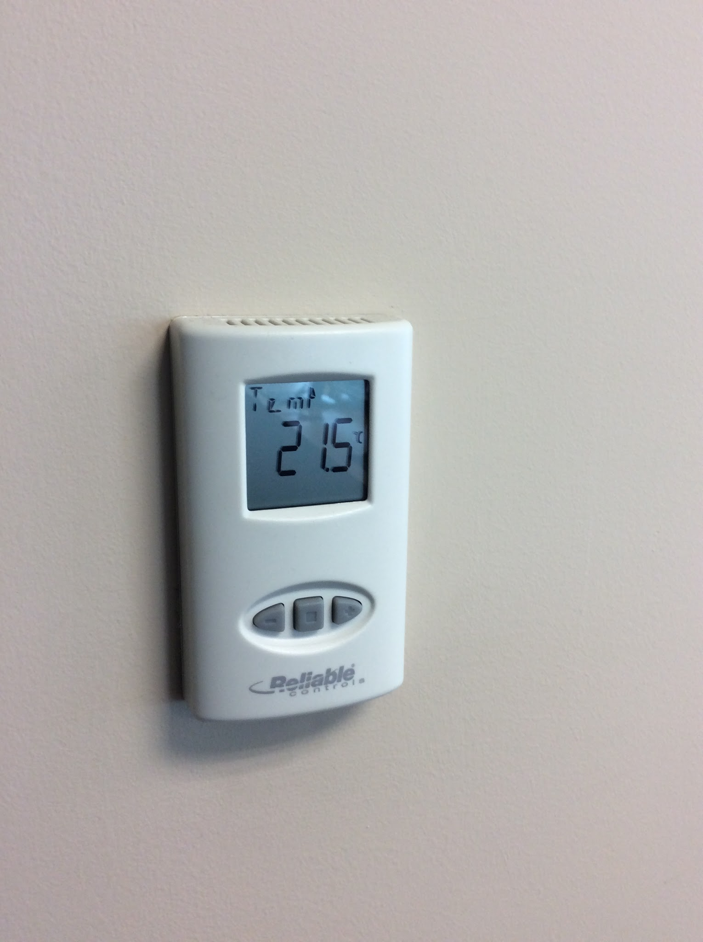Hands are kept off the thermostat. |  | 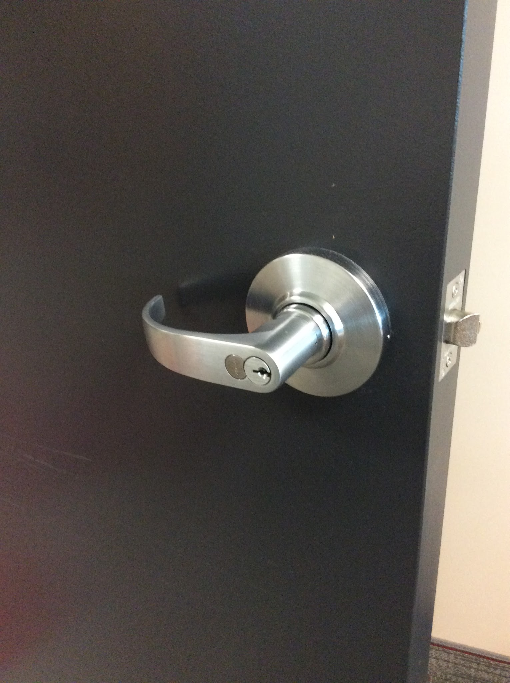The classroom door is to remain open when a teacher is not in the class.
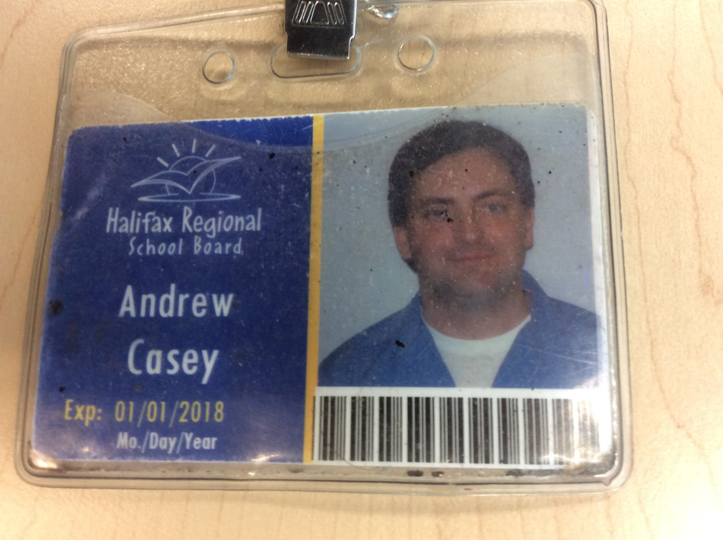Ask the teacher for help whenever needed. |  | 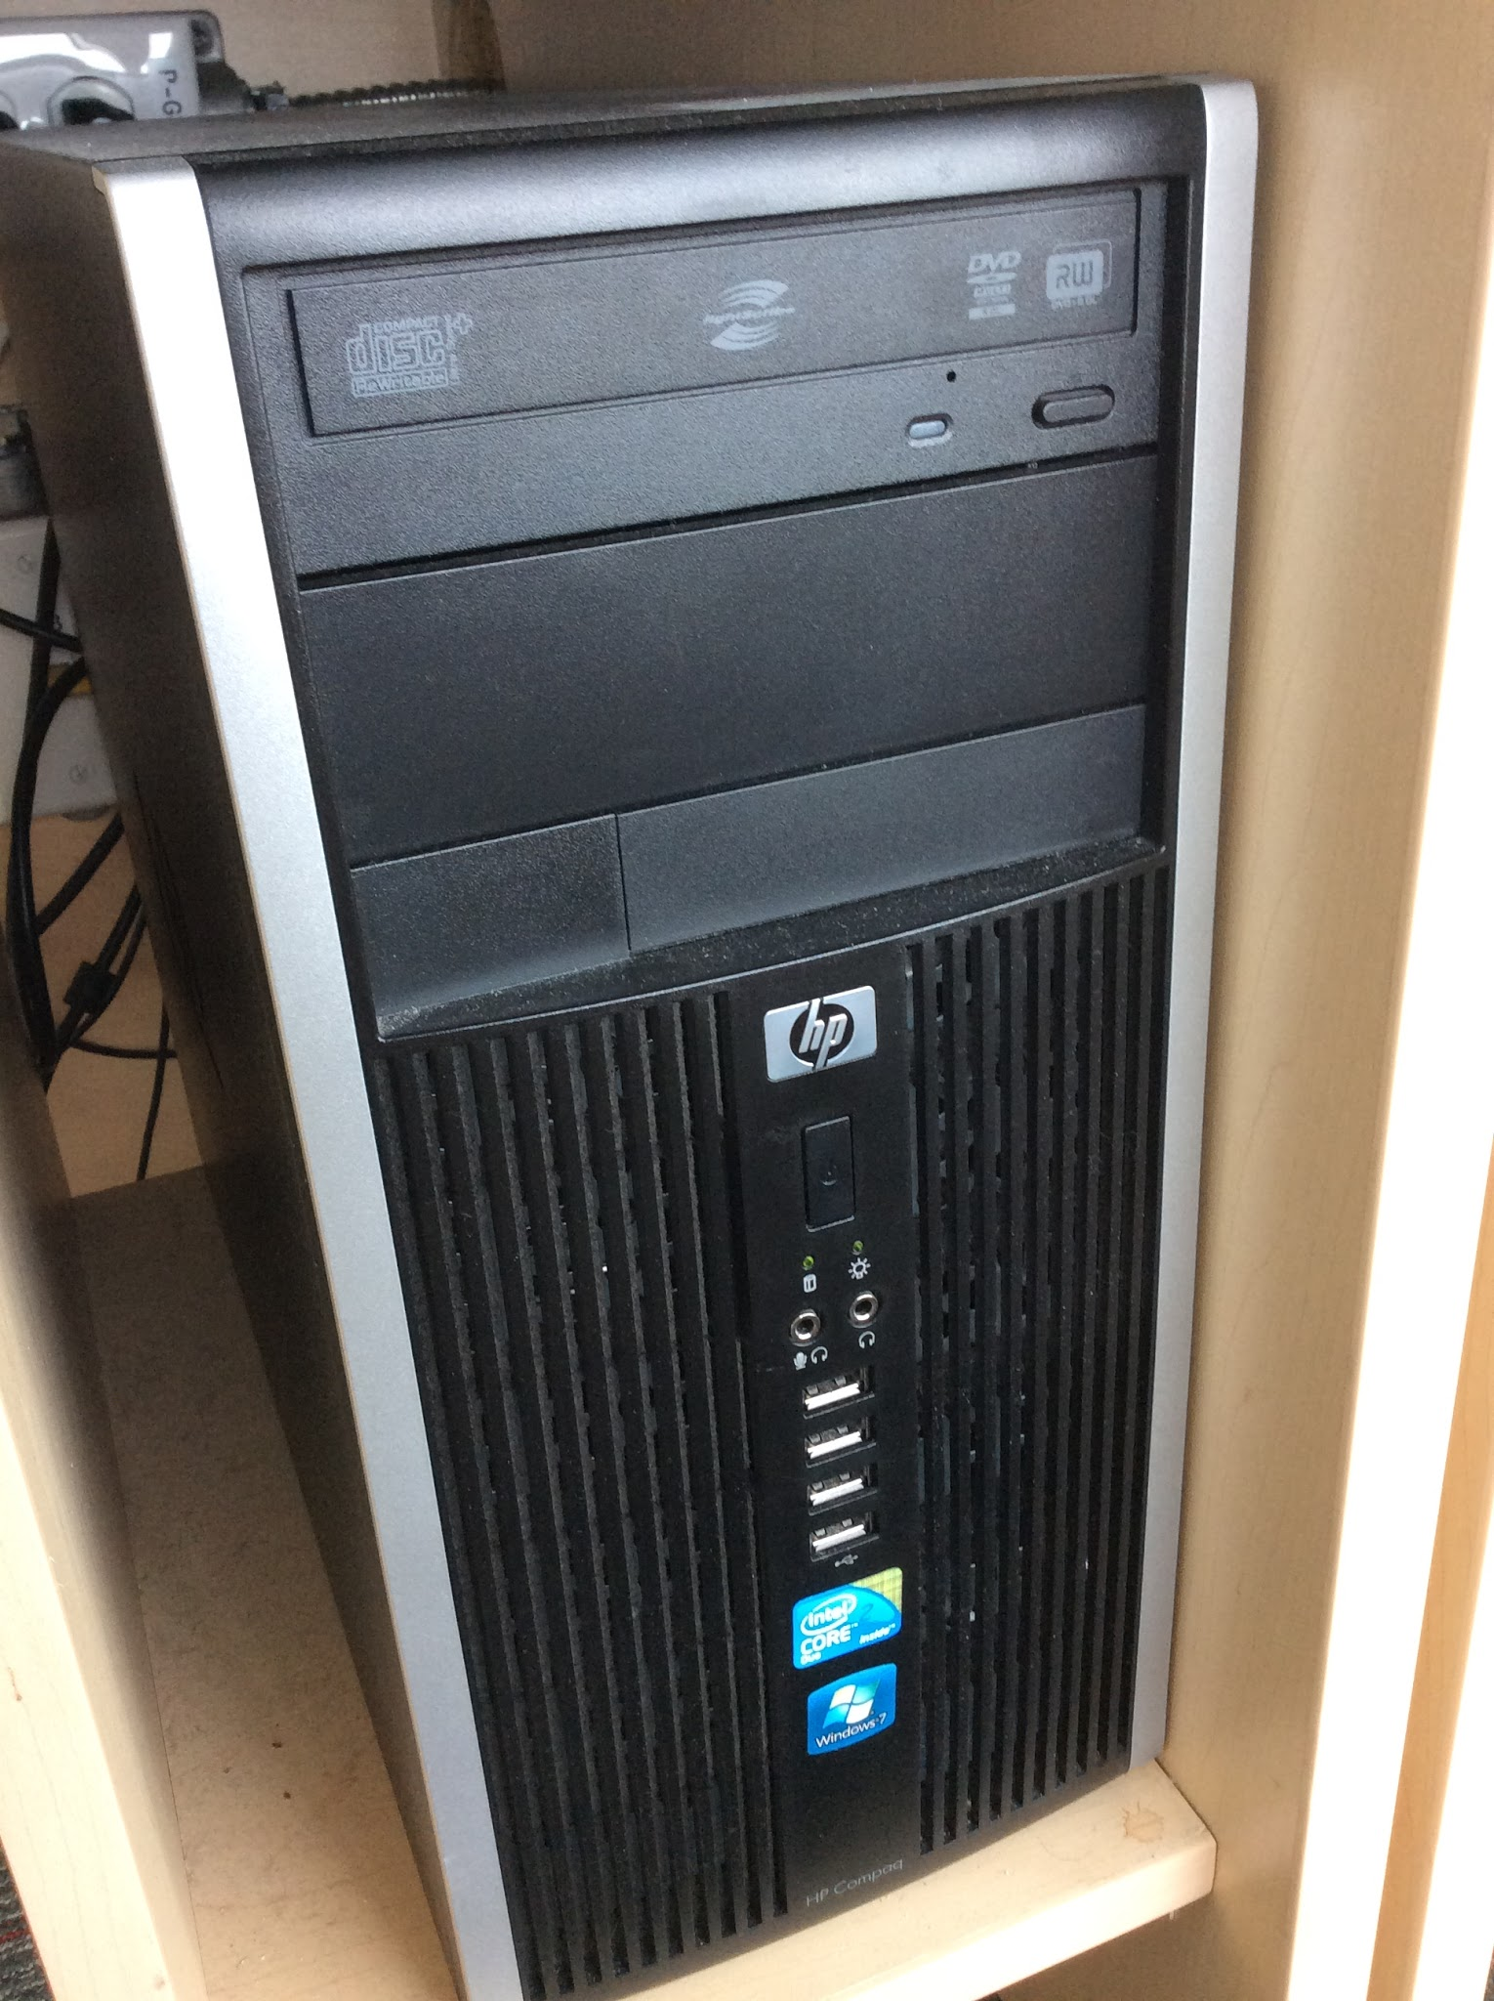Be sure to turn off your computer when finished.
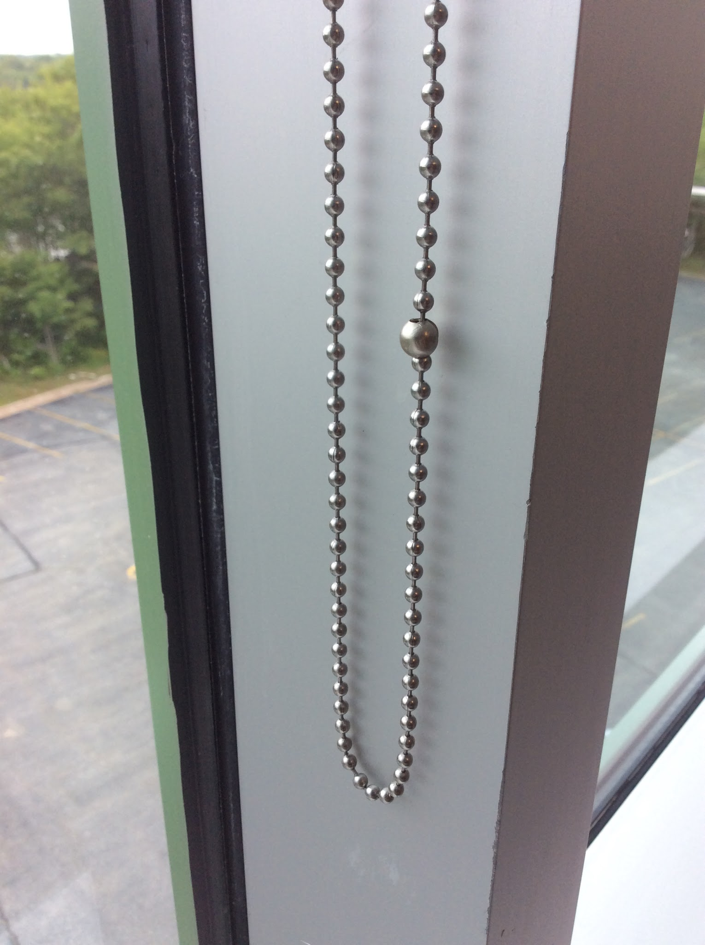Ask permission before touching the curtains. |  | 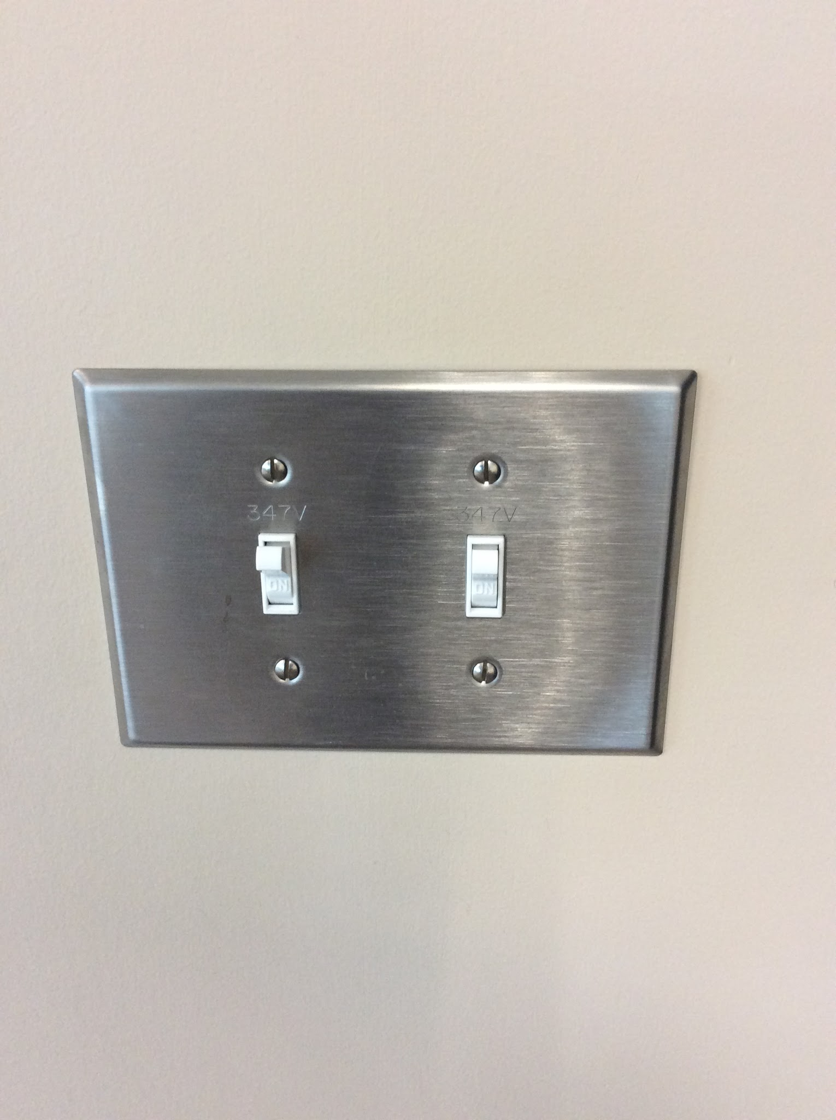Turn the lights off if you are the last one leaving the room.
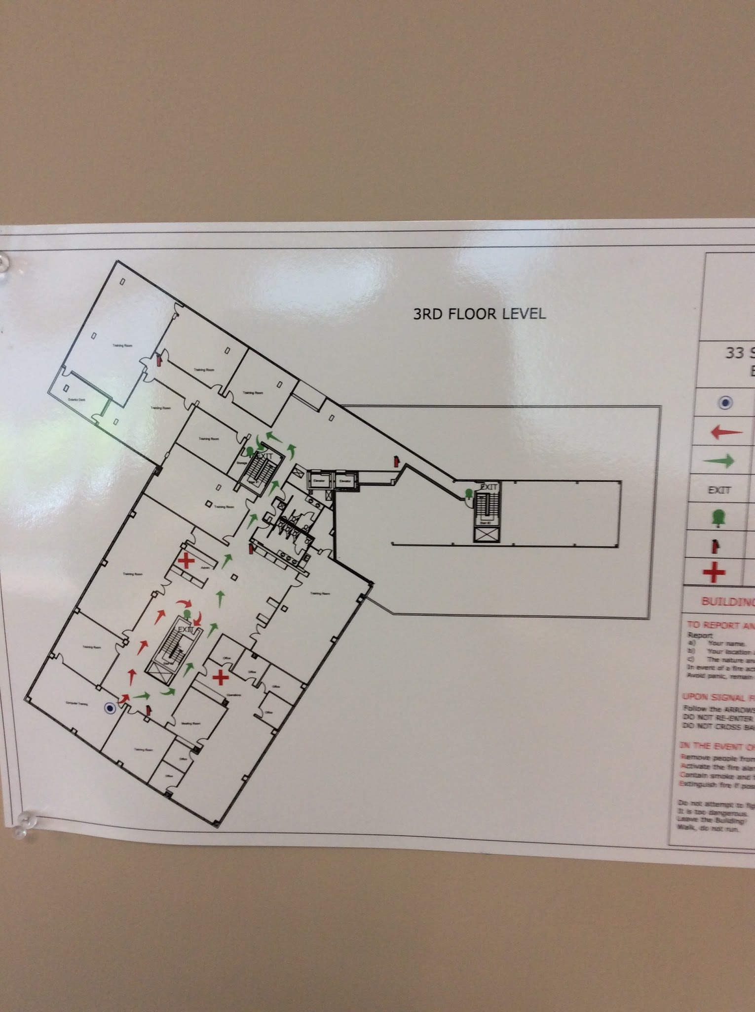Follow fire drill directions calmly. |  | Always remember who is in charge. :)

Step-By-Step Directions
1) Fill out your name on the handout and look at the board to find out what your Class Dojo monster (starter Casémon) looks like.
2) Write the number of your starter Casémon monster in the spot on the top right corner of your page as Student #.
3) Use the associated class rule for your starter Casémon as a hint for where to look for it in the classroom.
4) Grab your Casédex (Ipad or other device already locked on Aurasma) and search for your Casémon.
5) When you find it, position the Casédex (device) to get a clear image and then use the app to take a picture showing your Casémon with the associated rule’s image.
6) Colour in Caséball (Pokéball) on your sheet to show that it has been captured.
7) Go searching for the others in the class, using the other Casémon Trainers to help find the remaining Casémon, because you …..

