Grade:_4_ Subject: Language Arts Time-frame: _60 minutes________
Click here for online copy found at mrcaseyhrsb.weebly.com

Making Your Own Driving Question
(Lesson #4 from PBL: Who Am I?)
Driving Question: What type of question could help ‘drive us’ to learn more about something we are interested in?

Learning Targets:
- Language Arts
  - Outcome 7: Writing and other Ways of Representing
    - Students will be expected to use writing and other representations to explore, clarify and reflect upon thoughts and experiences.
- Technology
  - Outcome 5: Research, Problem Solving and Decision Making
    - Students will use digital tools to gather, record, share and interpret information and data to support learning.

Resources:
- LCD Projector
- Screencast on Creating a Research Question
- Interest Ribbons (7 sheets of 4)
- Question Ribbons (2 sheets of 12)
- class set of netbooks

Adaptations:
- printout of the Step-By-Step Directions
    - Check in to ensure they are properly participating with their partners

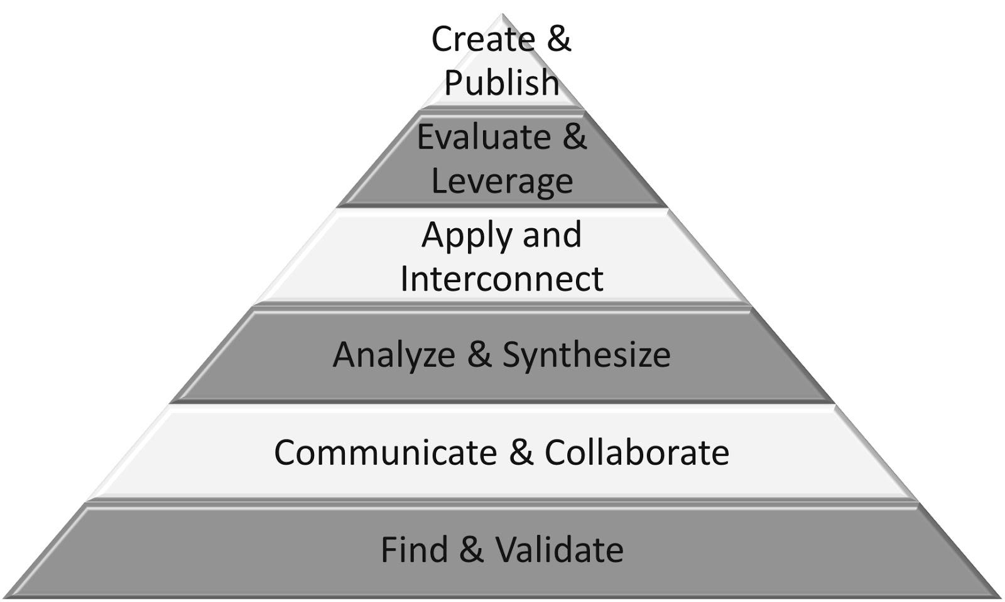
Part 1: (20 - 25 min) ✔

( ) Create & Publish
( ) Evaluate & Leverage
( ) Apply & Interconnect
(✔) Analyze & Synthesize
(✔) Communicate & Collaborate
(✔) Find & Validate

Connection

Introduction:
- Tell the students how there is a lot of things that need to be taught this year but how they are taught can still be affected by their input
- For example, the ability to research information, take notes, and then present that information is something we will need to do. But, what each student is researching about can be different for each student.

Guided Practice

- Tell them that today they will be looking closer into their interests and choosing something to spend a future day researching. It could be about anything they are interested in.
  - Take suggestions from the class of interesting topics
  - Remind them to look at their Cultural Flower and Me to We Image made in earlier lessons for ideas
  - Write their suggestions on ribbon cutouts and tape them on the board low enough so that they can be reached by all students
    - (Encourage a variety of interests like Pokemon, Shopkins, Olympics, Sydnry Crosby, Dragons, Horses, Narwhal, Minecraft, Gymnastics, etc)
  - Ask students to come up to the board with a pencil and add their name to the edge of any ribbon that contains something that interests them
    - It doesn’t have to be their favourite thing in the whole world, just something they do find interesting
    - Remind them that if their name is the only one on one of the ribbons, it simply shows something unique about them
    - Discourage them from trying to count how many picked a specific topic as if it is a contest

Explicit Teaching Teacher models/demonstrates

- Choose a differnt topic than any listed
  - (Example, juggling)
- Pose this lesson’s Driving Question
  - What type of question could help ‘drive me’ to learn more about juggling?

- Show Screencast on Creating a Research Question
  - key points to hilight
    - Not too easy that you can just search it up -
    - Not too hard that it needs a book
    - Needs to be specific
    - Don’t Worry! If it interests you, and gets you researching more information to learn something new, I will be happy!
- Demonstrate possible question development
  - visit wikipedia juggling site for ideas (not research, just ideas)
    - note the diagrams, math, history, then picture of juggler
    - “I’ve seen jugglers busking before.” → “The local Buskers Festival often has many jugglers.” → “I wonder how many of the buskers this year were jugglers?” → “How popular were they?” ……
    - Question: “What juggling acts were at the Buskers Festival this year and how well did they do?”
      - I can research the performers listed on website, news articles, twitter feedback tweets, final audience ranking of most popular acts etc.

Part 2: (15 - 20 min) ✔
( ) Create & Publish
( ) Evaluate & Leverage
(✔) Apply & Interconnect
(✔) Analyze & Synthesize
(✔) Communicate & Collaborate
( ) Find & Validate

Independent/Groups

- Students use netbooks to explore one of their topics of interest to generate their own research driving question
- They may work with others that are looking into the same topic of interest but would need to generate different specific questions concerning the topic
- Using a pencil, students write their research question on a Question Ribbon (long, narrow ones) and hold onto it.
- While waiting for others, they may start writing down some ideas in their writers notebook, or even making sketches or drawings related to their question so that a photo of it can be included later

Part 3: 5-10 minutes

(✔) Create & Publish
(✔) Evaluate & Leverage
( ) Apply & Interconnect
( ) Analyze & Synthesize
( ) Communicate & Collaborate
( ) Find & Validate
Time to Share
- As you post an Interest Ribbon to the “We are Awesome!” Bulletin Board, have any student with a related research question come up, read it out loud, and add it to the board.
- Try to hold the other students back from replying with an answer to the question but do remind the barer of the question that some of the students in the class may have opinions that can be looked into later (research phase)

- Finish with a reminder that they can be compiling information for their question anytime but will be given class time to do some research.

Step-By-Step Directions

1) Think of anything that interests you a lot.
- Take a look at you Cultural Flower of Me to We image for ideas

2) Add your name to any Interest Ribbon that you find interesting. (It doesn’t have to be your favourite.)
- Don’t worry what your friends put their name on, just think of what interests you.

3) Use wikipedia or other search locations to look into one of the topics that interests you.
- Reminder: don’t look for details, just question ideas

4) Write your research question on a Question Banner
- using pencil

5) Add ideas in your Writer’s Notebook or create possible drawings and sketches to go with your topic question

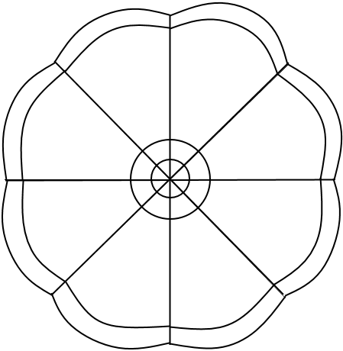
6) Hand in your Question Ribbon when topic mentioned.

