Grade:_4_ Subject: Health Time-frame: _60 minutes________
Click here for online copy found at mrcaseyhrsb.weebly.com

How to be a Good Digital Citizen
(Lesson #3 from PBL: Who Am I?)
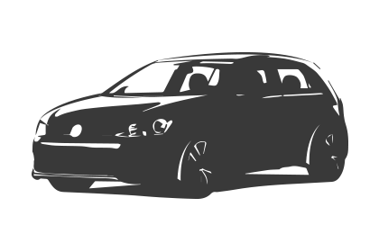Driving Question: How should I behave when I am venturing into
the digital world?

Learning Targets:
- Health
  - Outcome 2.2: Healthy Relationships
    - demonstrate an awareness of the link between positive self‐identity and making healthy decisions that affect relationships and care of self
- Technology
  - Outcome 1: Digital Citizenship
    - Students will understand and demonstrate behaviors which ensure their own and others health, safety and privacy.

Resources:
- LCD Projector
- Screencast on Digital Citizenship
- Mr. Potato Head Digital Citizen poster
- Smartboard or Mimio
- digital version of poster for use with Smartboard or Mimio
- Digital Citizen handout
- Digital Citizen handout answers

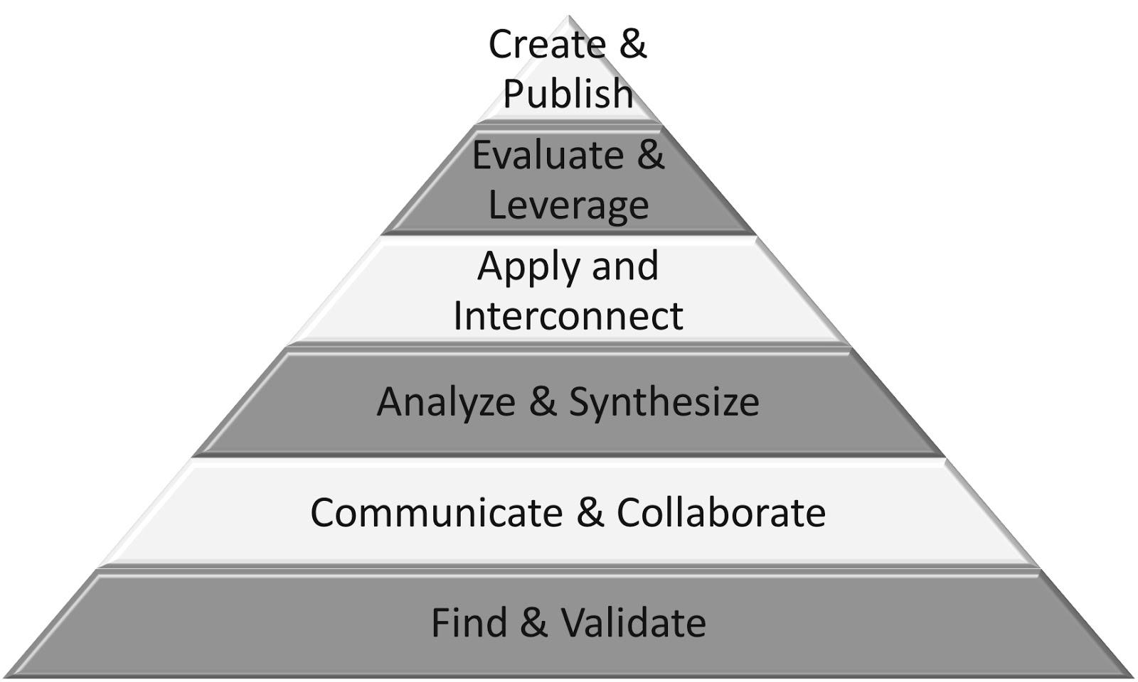
Part 1: (20 - 25 min) ✔

( ) Create & Publish
( ) Evaluate & Leverage
( ) Apply & Interconnect
(✔) Analyze & Synthesize
(✔) Communicate & Collaborate
(✔) Find & Validate

Connection

- Connect for students that when you take the big step from ‘Me’ to ‘WE!’, you are stepping into the global village and becoming a part of that community.
- When joining the rest of the world, you are expected to be a good citizen whether it is online or off.
- When interacting with the world online, you are referred to as a digital citizen.

Guided Practice
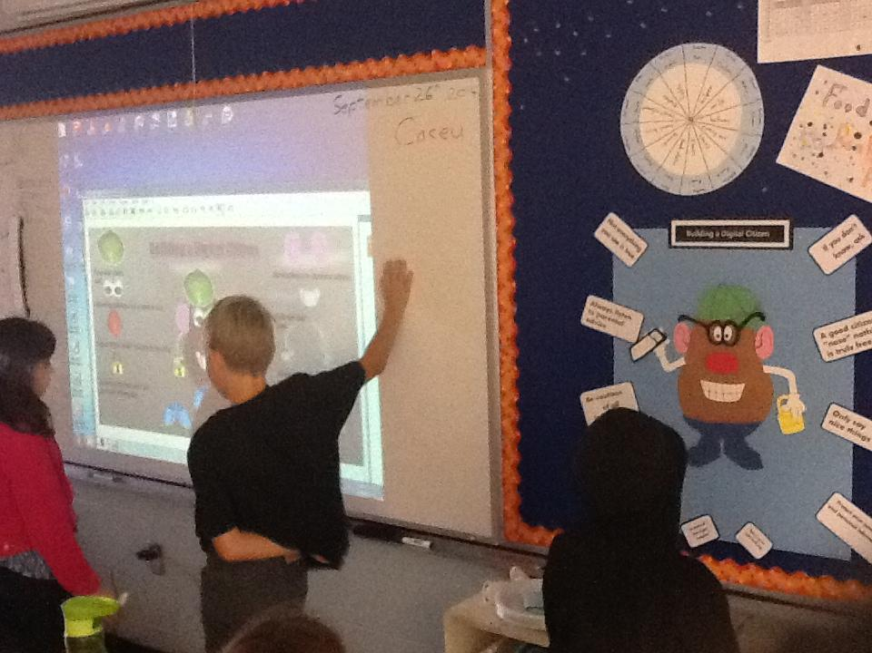
- Split the class into two teams

- one team is at the smart board (or Mimio) while the other team is at the poster

- On ‘go’, one student from each team goes to their Digital Citizen and moves one of the movable pieces to the matching label

- Warn that it can be tricky as there are only 10 labels but more than 10 movable parts (feet are separate yet arms and ears are in pairs)

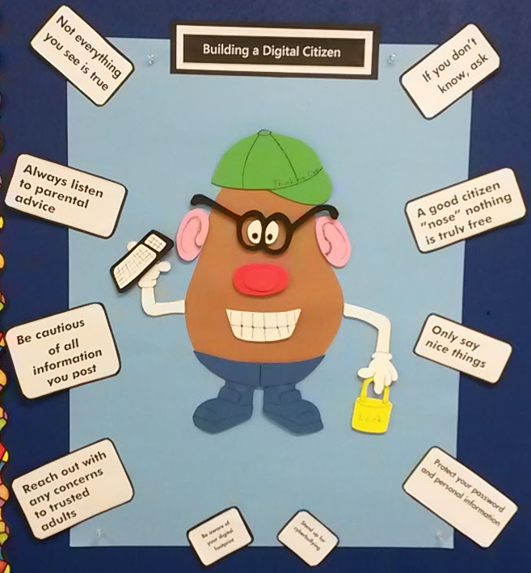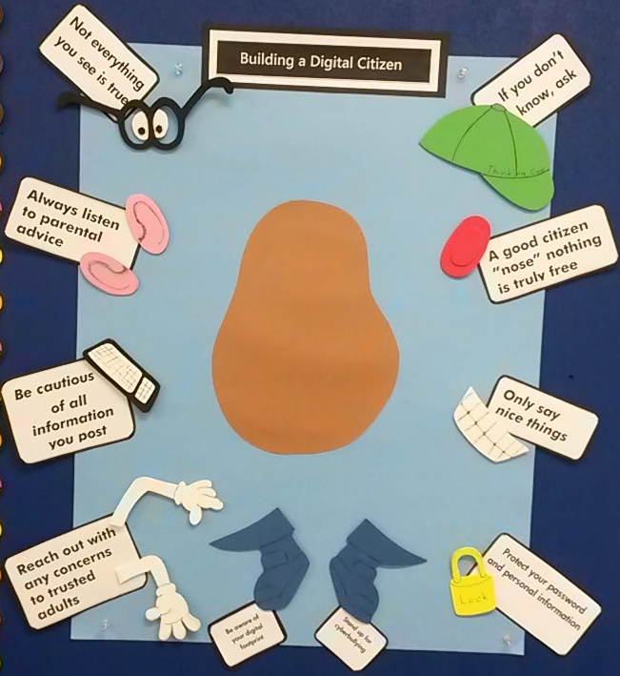

Explicit Teaching Teacher models/demonstrates

Play screencast to reveal the actual answer while students check to make sure the poster is correct.

Part 2: (15 - 20 min) ✔
( ) Create & Publish
( ) Evaluate & Leverage
(✔) Apply & Interconnect
(✔) Analyze & Synthesize
( ) Communicate & Collaborate
( ) Find & Validate

Independent/Groups
- Hand out Digital Citizen sheets
- Students write their name on the back
- students get to create their own Digital Citizen by drawing in the different pices the way they want them
- They fill in the labels as shown on the poster and draw a line to the matching pieces they drew on the Mr. Potato Head frame
Part 3: 5-10 minutes

(✔) Create & Publish
(✔) Evaluate & Leverage
( ) Apply & Interconnect
( ) Analyze & Synthesize
( ) Communicate & Collaborate
( ) Find & Validate
Time to Share
- When finished, students bring their new citizen forward to have its citizenship ID created
  - A picture of the Good Digital Citizen is taken and posted to the class website’s “Digital Classroom” page
    - make sure their name is not visible

Homework
- Parents and families are recomended to visit the page at home to see the digital citizens and then watch some of the other posted videos and images to continue the dialogue at home of proper “net”iquette

