Step-By-Step Directions

1) 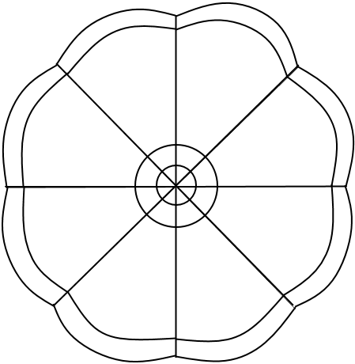 Fold your paper into 8 sections

2) Label the first section Family
3) Draw a simple image of something from your Cultural petal for Family
4) Label and draw images for the remaining petals:
- Language
- Sports
- Books
- Shows
- Food
- Hobbies
- Other
5) Use another paper to trace the 8 images, making one full one.
6) Colour your Me Image (don’t colour around image, just within it).
7) Cut out image, leaving a little trim of white around it.
8) Add finished product to the “We are awesome!” bulletin board.

