Grade:_4_ Subject: _Visual Arts Time-frame: _60 minutes________
Click here for online copy found at mrcaseyhrsb.weebly.com

Making a Cultural Flower
(Lesson #2 from PBL: Who Am I?)
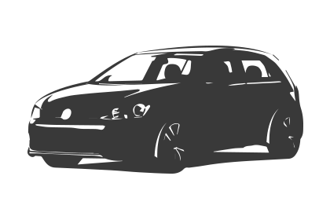Driving Question: If we are all different, yet alike, what are some of the things that make up who we are?

Learning Targets:
- Day 2: Visual Art
  - Outcome 1
    - Students will explore the creative process, individually and collaboratively, using a range of materials and technologies, to create with respect and sensitivity a variety of artworks that express feelings, ideas, and understandings.

Resources:
- LCD Projector
- Screencast on Making a Me Image
- Class set of netbooks
- chart paper
- black/dark markers
- white paper (2 per student)
- Empty Bulletin Board contatining title “We are awesome!”
- 25 pushpins

- Padlet sites
  - Family - Language - Sports
  - Books - Shows - Food
  - Hobbies - Other

Adaptations:
- printout of the Step-By-Step Directions
    - Check in to ensure they are properly participating with their partners

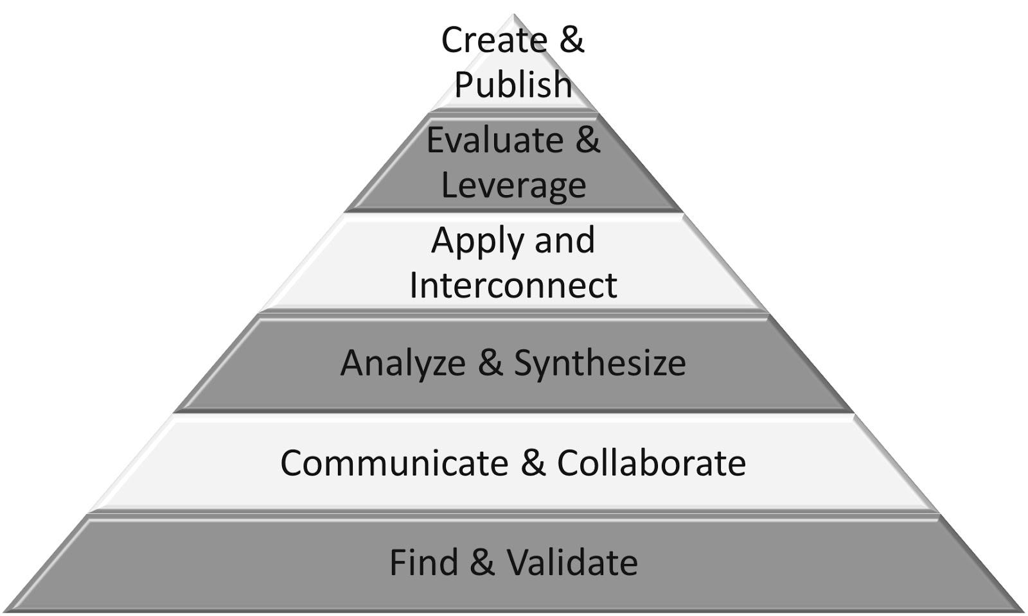
Part 1: (20 - 25 min) ✔

( ) Create & Publish
( ) Evaluate & Leverage
( ) Apply & Interconnect
(✔) Analyze & Synthesize
(✔) Communicate & Collaborate
(✔) Find & Validate

Connection

Introduction:
- Restate the driving question from last class:
  - If we are all different, yet alike, what are some of the things that make up who we are?

- Start by revisiting the Padlet sites and write one aspect from each on the white board to create your own ficticious character to use as an example for the class
  - Family - Language - Sports
  - Books - Shows - Food
  - Hobbies - Other

Guided Practice

- Show Screencast on Making a Me Image

Explicit Teaching Teacher models/demonstrates

- demonstrate on the white board, using traits compiled for ficticious character
  - ask for volunteers to help draw some of the images on board
  - use a piece of chart paper to trace and compile Me Image

Part 2: (15 - 20 min) ✔
(✔) Create & Publish
( ) Evaluate & Leverage
(✔) Apply & Interconnect
(✔) Analyze & Synthesize
(✔) Communicate & Collaborate
( ) Find & Validate

Independent/Groups

- Step 1: Creating Images
  - students fold their paper into 8 pieces
  - label each section with
    - Family - Language - Sports
    - Books - Shows - Food
    - Hobbies - Other
  - students add a simple image to each block, representing something about them
  - they can use netbooks to search for something to use as an image but must draw it themselves

- Step 2: Compiling Images
  - students use a new piece of paper to trace their images to create a compiled image
  - they should start with their favourite image for their foreground and trace in below the half way point on the page, leaving plenty of room for the remaining images
  - when all 8 images are added, they can colour inside the image but leave the outside white

Part 3: 5-10 minutes

(✔) Create & Publish
(✔) Evaluate & Leverage
( ) Apply & Interconnect
( ) Analyze & Synthesize
( ) Communicate & Collaborate
( ) Find & Validate
- Step 3: Publish Images
  - students cut out their image (leaving a little bit of white trim around the overall image)
  - put name on the back
  - bring it up to the “We are awesome!” bulletin board and find a place to place it on the board that slightly overlaps or is overlapped by another student’s work. (do not entirely block any symbol)

Time to Share
- Direct students to view overall image and notice how it has unique pieces, and similar pieces
- point out that all those pieces together, help make this an awesome class
- it will be through the different cultures, experiences, and interests of this class, that this year will be great
- Take a picture of the entire image to act as a symbol of who we are as a class and have students picture what would one look like if we did one as a school, or a country, or the planet!

Step-By-Step Directions

1) 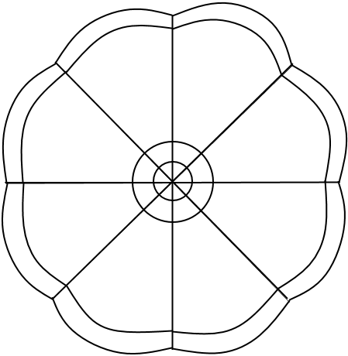 Fold your paper into 8 sections

2) Label the first section Family
3) Draw a simple image of something from your Cultural petal for Family
4) Label and draw images for the remaining petals:
- Language
- Sports
- Books
- Shows
- Food
- Hobbies
- Other
5) Use another paper to trace the 8 images, making one full one.
6) Colour your Me Image (don’t colour around image, just within it).
7) Cut out image, leaving a little trim of white around it.
8) Add finished product to the “We are awesome!” bulletin board.

