Grade:_4_ Subject: _Health Time-frame: _1-2 days________
Click here for online copy found at mrcaseyhrsb.weebly.com

Making a Cultural Flower
(Lesson #1 from PBL: Who Am I)
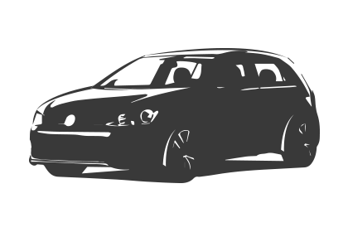Driving Question: If we are all different, yet alike, what are some of the things that make up who we are?

Learning Targets:
- Day 1: Health
  - 1.6 explore their skills and interests in relation to potential life goals
    - reflect on likes and dislikes
    - investigate personal learning styles
    - reflect on understanding of self

Resources:
- LCD Projector
- Screencast on Meet Mr. Casey
- Class set of netbooks
- Padlet sites
  - Family
  - Language
  - Sports
  - Books
  - Shows
  - Food
  - Hobbies
  - Other

- Cultural Flower Google Slide

Adaptations:
- printout of the Step-By-Step Directions
    - Check in to ensure they are properly participating with their partners

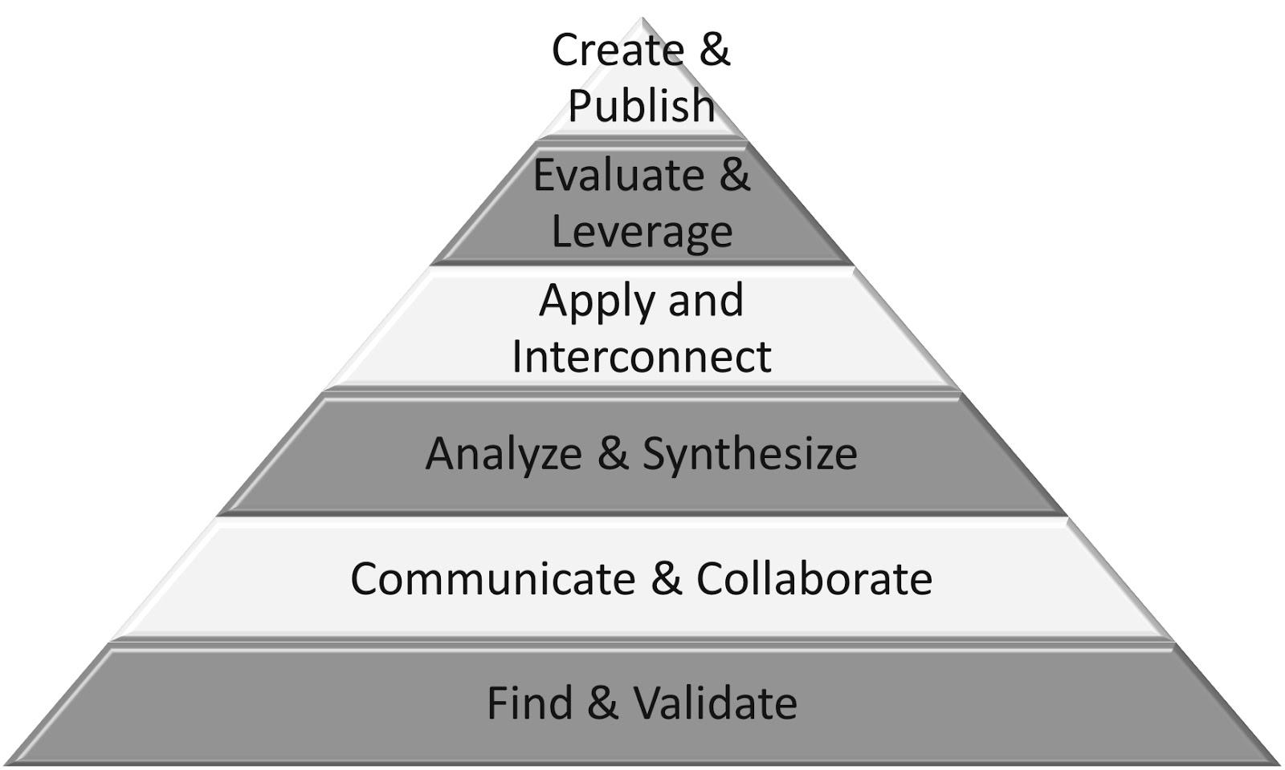
Part 1: (20 - 25 min) ✔

( ) Create & Publish
( ) Evaluate & Leverage
( ) Apply & Interconnect
(✔) Analyze & Synthesize
(✔) Communicate & Collaborate
(✔) Find & Validate

Connection

Introduction:
- (beginning of school year introduction)
- Start by playing stop motion introduction
  - Screencast on Meet Mr. Casey
  - touch on a few key points of the year!
  - My motto: Look at Big Maps!
    - when thinking of your community, don’t just include the people in this room, or even the town, think of the biggest map you can, the global community
  - Who we are as a class and what we are interested in can be the driving force of the school year. But first, I need to know about you.

- Pose the driving question:
  - If we are all different, yet alike, what are some of the things that make up who we are?

Guided Practice

- Ask the class what culture means to them
  - steer discussion towards it referring to the aspects of us that we have taken from being part of a group. (boy, girl, young, old(er), gamer, athlete, nationality, language, family heritage, etc)
  - all those experiences help shape us but can not be assumed to be a part of us
    - ex, just because someone is a girl, does not mean you know their view of the colour pink.

Explicit Teaching Teacher models/demonstrates

- handout Cultural Flower sheets
  - put name on back of sheet
  - Project slideshow onto white board so that you can fill in information as it progresses
    - Click to start slideshow
      - students copy heading “Family”
      - teacher adds detail to cultural flower petal on board as demonstration

Part 2: (15 - 20 min) ✔
(✔) Create & Publish
(✔) Evaluate & Leverage
(✔) Apply & Interconnect
(✔) Analyze & Synthesize
( ) Communicate & Collaborate
( ) Find & Validate

Independent/Groups

      - students fill in own flower petal with info they want to share about family
      - any aspect they want to share (example, me, mom, 5 sisters, and 3 brothers, 7 of 9 adopted)
      - students go to padlet site listed on slideshow to add their detail to that petal’s padlet page
      - Note: if students are having a difficult time thinking of what to write, they can check the padlet site for ideas from their peers but are reminded to only put it in their flower if it truly matches themselves

  - progress slide show to show next petal
  - continue alternating between teacher example and independent work as slides progress through remaining petals
  - Students can colour flower but are not to colour over written words, just around them

Part 3: 5-10 minutes

(✔) Create & Publish
(✔) Evaluate & Leverage
( ) Apply & Interconnect
( ) Analyze & Synthesize
( ) Communicate & Collaborate
( ) Find & Validate
Time to Share
- Flip through Padlet pages while having students reflect on noticable similarities and differences
  - Family
  - Language
  - Sports
  - Books
  - Shows
  - Food
  - Hobbies
  - Other
- Students cut out flowers and hand them in to be posted as a trim lining the top of the front white board.

Step-By-Step Directions

1) 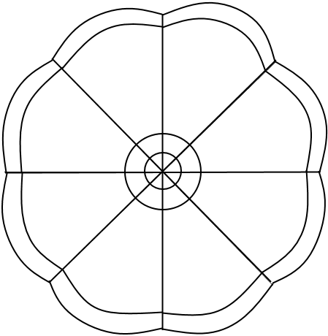 Put your name on the back of your flower sheet.
2) Label the first petal ‘Family’.
3) Fill in simple jot-notes about the makeup of your family.
- If you are having trouble, check out what others have written on the padlet site:
    - padlet.com/mrcaseyhrsb/family
4) Add your information to the padlet site for Family
5) Continue for the remaining petals:
- Language
- Sports
- Books
- Shows
- Food
- Hobbies
- Other
6) Colour in the flower without colouring over your written words.
7) Cut out your flower.
8) Double check your name is still on the back and then hand it to be displayed.

Cultural Flower

