Grade:_4_ Subject: Social Studies Time-frame: _90 minutes________
Click here for online copy found at mrcaseyhrsb.weebly.com

The Flag of We: Augmented Reality
(Lesson #10 from PBL: Who Am I?)
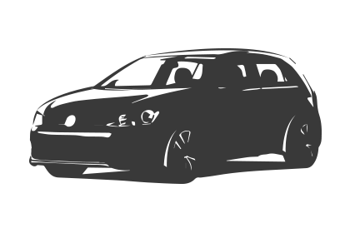Driving Question: When exploring new ideas and technology, can we discover new things and plant our flag of success?

Learning Targets:
- Social Studies
  - Outcome 1
    - Students will examine the concept of exploration.
      - exploring is about curiosity, problem solving, creativity, and innovation
- Technology
  - Outcomes 4: Productivity and Innovation
    - Students will use digital tools to plan, create, and publish their work both individually and collaboratively.

Resources:
- LCD Projector
- Screencast on We Flag
- Screencast on DoInk
- class set of ipads or other devices (need apps Quiver and DoInk)
- green screens (green plastic table cloth or shower curtain work well)
- class banner
- class poster
- 4-5 netbooks

Adaptations:
- printout of the Step-By-Step Directions
    - Check in to ensure they are properly participating with their partners

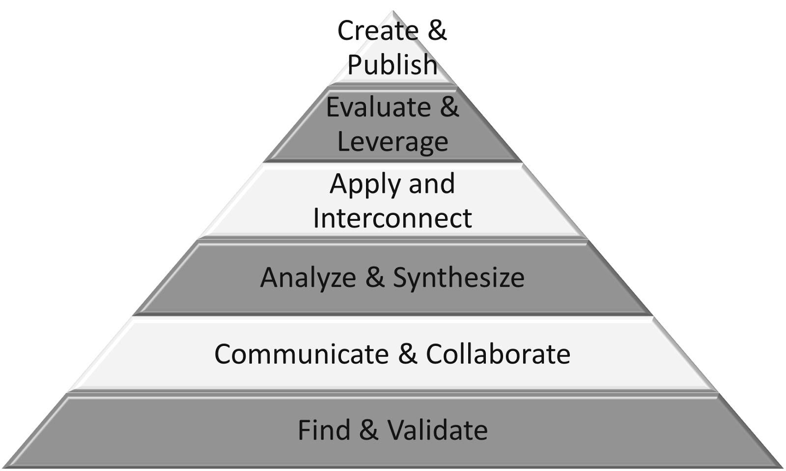
Part 1: (20 - 25 min) ✔

( ) Create & Publish
( ) Evaluate & Leverage
( ) Apply & Interconnect
(✔) Analyze & Synthesize
(✔) Communicate & Collaborate
(✔) Find & Validate

Connection

- Remind students of the beginning of this large project.
  - It started with self discovery within the cultural flower.
  - Then it moved to the Me image that joined other images to create a full class We image.
  - Those cultural uniqueness and similarities helped create driving questions that in turn developed new discoveries shown in the slide show.
  - All this accomplished while adventuring through new technologies that revealed hidden secrets.

Guided Practice

- Ask the class what that journey makes them into
  - Hints: self discovery, adventuring, new discoveries, hidden secrets etc!
- Show them the new banner for the class door
- Have further discussion on what it means to be an explorer.
  - Gr.4 Curriculum reminds us
    - exploring is about curiosity, problem solving, creativity, and innovation

- Discuss how, in the past, explorers of new lands often planted a flag in their newly “conquered” land as a way of separating people into us and them.

Explicit Teaching Teacher models/demonstrates

- Today the explorers from this class will plant a flag that is more inclusive: a flag for the world
- show Screencast on We Flag

Part 2: (15 - 20 min) ✔
( ) Create & Publish
(✔) Evaluate & Leverage
(✔) Apply & Interconnect
(✔) Analyze & Synthesize
(✔) Communicate & Collaborate
( ) Find & Validate

Independent/Groups

- Hand out step-by-step directions to everyone but warn them that not all steps are listed in detail, some need some exploration to be revealed
- remind students before they attempt their We Flag, that they will need to problem solve and be innovative in their steps forward but there are many supports available for them
- There will be netbooks available already set with the We Flag screencast and the DoInk app has a screencast built in as well.
- Remind them to ask peers for help after trying to figure it out on their own
- As a last reminder to stick to tackling difficulties ahead, put up the new class motto poster

Part 3: 5-10 minutes

(✔) Create & Publish
(✔) Evaluate & Leverage
( ) Apply & Interconnect
( ) Analyze & Synthesize
( ) Communicate & Collaborate
( ) Find & Validate
Time to Share
- Share the videos the students posted in the Google classroom
- Have students recount their journey of discovery by sharing their pitfalls and eureka moments
- Celebrate all accomplishments as a successful exploration into new territory

Step-By-Step Directions

1) Design and colour a flag that you feel represents all people of the world. You don’t need to actually draw any people at all. The flag is meant to be symbolic.
2) Turn on the Quiver app on your iPad and bring your flag to life as shown in the screencast.
3) While making sure the flapping flag is surrounded by the green screen, take an in-app video of your flag flying.
4) Find an image of the earth on Google that you want the flag to stick on and save it to the Photo Gallery
5) Using the app DoInk, add the Earth photo to the bottom layer and then the flag video onto the second layer.
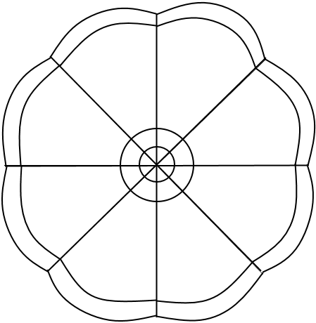
6) Position the flag image where you want it and the size you like. Click on the colour wheel to adjust the green screen.
7) Click on the mask to erase the unwanted parts of the screen. Revisit screencast for visuals.
8) Use the app to save a new copy of the flag flying.

9) Upload the video to Google Classroom.
Class Motto

